NESP HUB INDIGENOUS RESEARCH

PROJECTS – LOCATION AND REGIONAL GAPS

Introduction and Approach
This Chapter examines the geo-spatial location of the selected Indigenous research projects of each of the NESP Hubs against a number of different thematic layers of geo-spatial information.
The brief required SGSEP to identify regions where Indigenous research themes and questions have not been found online. To perform this task we needed to map the geo-spatial location of the selected Indigenous research projects of each of the NESP Hubs to ascertain where Indigenous environmental and climate science research has taken place and where there may be geographic gaps in Indigenous research.
In approaching this task, SGSEP also decided that there would be some added value by mapping the selected Indigenous research projects against a number of different thematic layers of geo-spatial information. Using the projects that SGSEP selected or were guided to by the Hubs on the basis of having a high level of Indigenous engagement, we were able to map them against the following thematic layers of geo-spatial information:
    - State/Territory;
    - Australia’s Marine BioRegions (MB Hub projects only);
    - Australia’s Terrestrial BioRegions;
    - NRM Regions;
    - Indigenous Protected Areas;
    - The Indigenous estate.
The selected thematic layers of geo-spatial information depended on the availability and compatibility of the relevant geo-spatial data.
From this analysis, we are able to make some observations about the connections, or lack thereof, between the Indigenous environmental and climate science research projects undertaken by the NESP Hubs and the various layers of geo-spatial information. We conclude there is considerable value in developing stronger correlations between the environmental and climate science research and the other thematic layers of
information about Australia’s environment and land matters that will provide some useful guidance on research priorities for the next iteration of the Program.

Spatial Mapping of Indigenous NESP Hub Research Projects:
As discussed in Chapter 3, in order to ascertain an understanding of the nature of Indigenous engagement in NESP Hub research activities, SGSEP undertook a closer examination of a selection of 108 research projects that we were guided to by the Hubs or that we selected on the basis of having a high level of Indigenous engagement. Figure 5.1 shows the selected Indigenous NESP projects by Hub that we were able to map against a particular locality. It shows that the majority of projects are located predominantly in northern Australia. The projects included in our analysis but not included in the spatial mapping in this Chapter are listed in Appendix I.
The maps in this Chapter show the location of the selected NESP Hub projects by various environmental or other significant layers to ascertain an understanding of the relationship between the NESP Indigenous

research activities and the other layers of geospatial information or theme. It is important to note that the maps in this Chapter do not reflect all of the NESP Hub Indigenous research projects. However, the maps can be read as generally indicative in terms of their relationship between the selected NESP Hub Indigenous research projects and a particular layer of information.
It is also important to note that three of the Hubs have responsibilities for a particular geographic area:
    - The geographic scope of the NAER Hub’s research is on Northern Australia only.
    - The geographic scope of the TWQ Hub’s research is focussed on the Great Barrier Reef, the Torres
Strait and other tropical waters.
    - The geographic scope of the CAUL Hub is on urban environments in our major cities and regional centres.
These geographic factors therefore skew the results predominantly toward northern Australia.
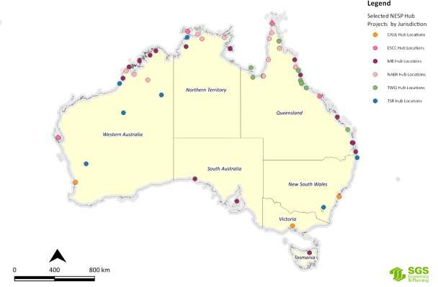
Figure 5.1: Selected NESP Indigenous research projects by Hub and Jurisdiction as at March 2020
Source: SGS Economics and Planning using NESP Hub Data, 2020

State/Territory
Figure 5.1 also shows that the jurisdictions with the least number of Indigenous NESP Hub research projects are the Australian Capital Territory, South Australia, Tasmania, New South Wales and Victoria. More detailed maps of the selected NESP Hub projects by jurisdiction are in Appendix J.

Australia’s Marine BioRegions
The framework for Australia’s Marine Bioregions, the National Representative System of Marine Protected Areas (NRSMPA) and Australia’s Marine Parks (AMP) was discussed in Part 4.2 of Chapter 4 (and Appendix H). The Integrated Marine and Coastal Regionalisation of Australia (IMCRA v4.0) (Figure 4.2) is a spatial

framework for classifying Australia's marine environment into bioregions which form the basis for the development of a National Representative System of Marine Protected Areas (NRSMPA).
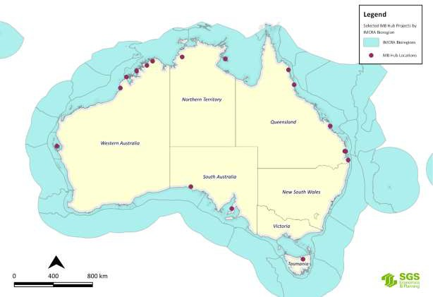Using Figure 4.2 in Chapter 4, Figure 5.2 maps the Marine Biodiversity Hub’s selected Indigenous research projects against the IMCRA Bioregions. Figure 5.2 shows that most of the MB Hubs projects are concentrated in the tropical waters and transition areas with fewer projects in the subtropical waters and cold temperate waters, reflecting the Australian Government’s general policy interest in developing the north, as well as the marine areas under the greatest pressures and the areas of strong interest by TOs.
Figure 5.2: Selected MB Hub Indigenous research project locations by IMCRA Bio Regions
Source: MB Hub and SGS Economics and Planning and DAWE data, 2020.
Using Figure 4.3 in Chapter 4 and Figure H17 in Appendix H, Figure 5.2 maps the location of all the selected NESP MB Hub Indigenous research projects against Australia National Reserve System and National Representative System for Marine Protected Areas. Figure 5.2 shows that the MB Hub’s projects are spread across most of the Marine Park areas in the northern and western areas of Australia in the waters around Tasmania, but none or very few in the waters around South Australia, Victoria and New South Wales.

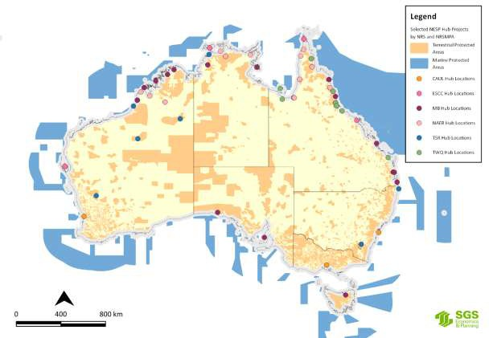
Figure 5.3: Selected NESP Hub Indigenous research projects by NRS and NRSMPA
Source: SGS Economics and Planning utilising NESP Hub data, 2020.

Australia’s Terrestrial BioRegions;
The framework for Australia’s Bioregions and NRS was discussed in Chapter 4. The Interim Biogeographic Regionalisation for Australia (IBRA) (Figure 4.4) and Terrestrial Ecoregions of Australia (Figure 4.5) are a spatial framework for the systematic development of a comprehensive, adequate and representative NRS in Australia. The IBRA classifies Australia's landscapes into 89 large geographically distinct bioregions based on common climate, geology, landform, native vegetation and species information.
Using Figure 4.4 in Chapter 4 and Figure H16 in Appendix H, Figure 5.4 shows the selected NESP Hub Indigenous research project locations by IBRA regions. A closer inspection of the data behind these maps shows that some of the NAER Hub and TWQ Hub projects are in areas that are under-represented in the NRS, especially in Queensland and the Northern Territory and we are informed by the Hubs that the research outcomes are adding valuable knowledge and understanding about various environmental matters in these areas.

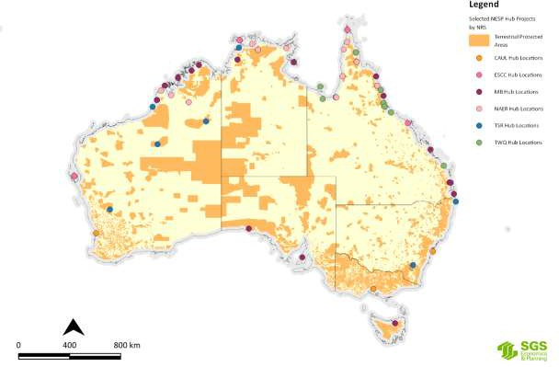

Figure 5.4: Selected NESP Hub Indigenous research projects by National Reserve System (NRS)
Source: SGS Economics and Planning utilising NESP Hub data, 2020

Indigenous Protected Areas
As discussed in Chapter 4, there are 76 dedicated IPAs in Australia, covering approximately 67 million hectares and accounting for more than 45 per cent of the National Reserve System's total area (Figure 4.4). There are also 12 more sites currently under consultation (Appendix H).
Using Figure 4.4 in Chapter 4, Figure 5.5 shows the selected NESP Hub projects against a map of the 76 IPAs and 12 IPA sites under consultation. Figure 5.5 shows that for some Hubs there are a large number of projects involving several IPAs. For example, the NAER, ESCC and TSR Hubs undertook several research projects that had a national focus and therefore related to more than one IPA.
IPAs are important to Indigenous Australians because the declaration of an IPA is undertaken in consultation with the relevant TOs and a management plan has to be prepared by the entity that will be appointed to manage the IPA before the declaration is finalised. This means that an IPA Management Plan carries a considerable degree of authenticity about what the TOs see as threats to the place and its values and how a place should be managed. IPA Management plans may also identify matters where research is required either to better understand the nature of threats or how to improve monitoring and management techniques to ensure the place continues to protect the values for which the place was dedicated as an IPA. For these reasons we examine the IPA Management Plans in more detail in Chapter 6.

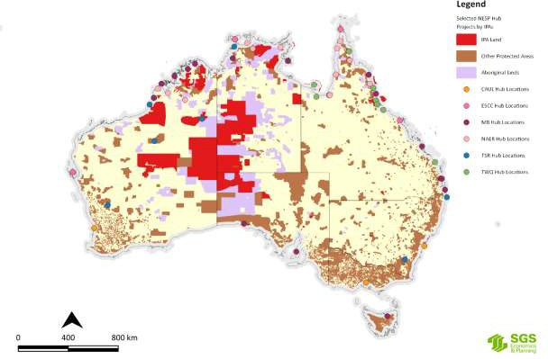

Figure 5.5: Selected NESP Hub Indigenous research projects by Indigenous Protected Areas (IPAs)
Source: SGS Economics and Planning utilising NESP Hub data

The NLP and NRM Regions
As discussed in Part 4.2 of Chapter 4, the Regional Land Partnerships component of the National Landcare Program provides funding for 49 management units across Australia (Figure 4.6) to deliver particular outcomes, including engagement with Indigenous peoples and the utilisation of their IK for the achievement of environmental and agricultural outcomes.
Utilising the interactive map of the 56 regional NRM organisations³¹ and Figure 4.6 in Chapter 4, Figure 5.6 shows that many of the NRM Regions have a very low number of Indigenous NESP Hub research projects in their respective areas of interest. What this suggests is that there is little or no correlation between Indigenous NESP Hub research activities and Indigenous NRM projects funded under the National Landcare Program. A closer examination of NESP and NLP projects is required to verify the extent of any correlation, especially in terms of the NLP as an end user of NESP research outcomes.

31 http://www.nrm.gov.au/indigenous-nrm/telling-the-story

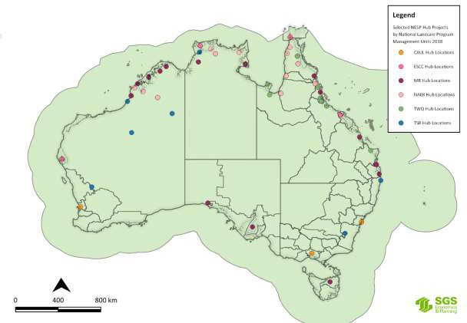

Figure 5.6: Selected NESP Hub Indigenous research projects by National Landcare Program Management Units
Source: SGS Economics and Planning utilising NESP Hub data, 2020

The Indigenous Estate
Recent research has shown that the extent of land owned, managed or controlled by Aboriginal and Torres Strait Islander peoples is increasing over time. This is referred to as the ‘Indigenous estate’ by several academics (Altman and Kerins, 2012; Wensing, 2016) and the Indigenous Property Rights Network (AHRC, 2016). The Indigenous Estate is defined by the Indigenous Property Rights Network as encompassing ‘the lands, seas, waters and resources of Aboriginal and Torres Strait Islander peoples’ (AHRC, 2016:1). The different components of the Indigenous Estate are listed in Appendix L.
Altman’s (2014) research reveals that the extent of the Indigenous estate is around 2.5 million square kilometres, or roughly 33 per cent of terrestrial Australia. Figure 5.7 shows the extent of the Indigenous estate under the following three tenure types:
      - Land claimed or automatically scheduled under statutory land rights schemes (an estimated 969,000 sq kms as at 2013);
      - Native title determinations of exclusive possession (92 determinations totalling 752,000 sq kms); and
      - Native title determinations of non-exclusive possession (142 determinations totalling 825,000 sq kms).
Altman (2014:5) notes that the last category often provides a weak form of property right that needs to be shared with other interests, most commonly commercial rangeland pastoralism. The data used to compile this map was current as at 31 December 2013 and only relates to the terrestrial estate, and does not include the marine estate.

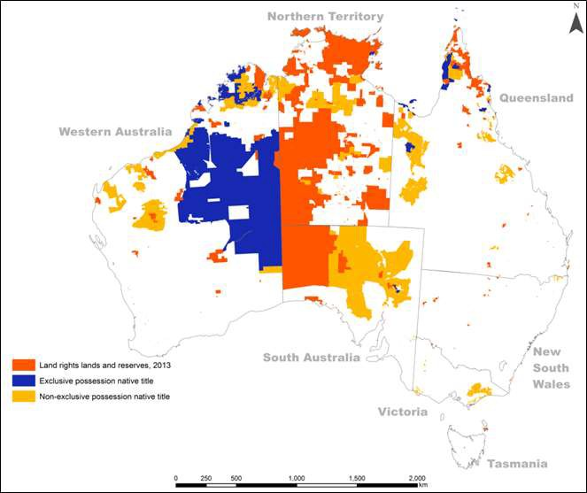

Figure 5.7: The Indigenous estate under three land titles (as at 2013)
Source: Altman 2014:6
Altman’s (2014) research also highlights the relationship between three different environmental values overlaying a template of lands of exclusive land rights and native title possession over Australia.
Figure 5.8 shows a marked contrast between exclusive possession native title and Indigenous lands and vegetation condition.

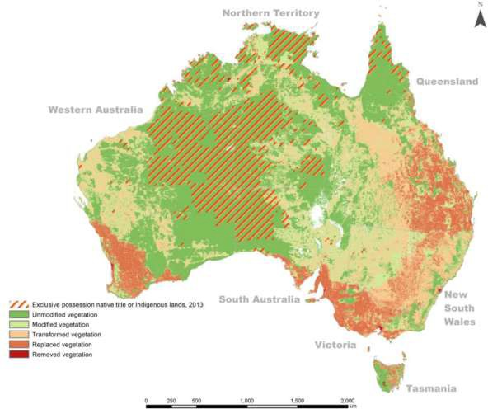
Figure 5.8: Vegetation condition (2006) and exclusive possession native title or Indigenous lands (2013)
Source: Altman 2014:10

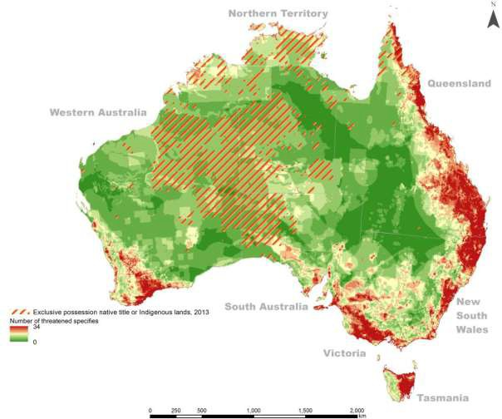Figure 5.9 also shows a marked contrast between exclusive possession native title and Indigenous lands and official threatened species counts, particularly in the more densely settled areas in the east, south east and south west of the continent.
Figure 5.9: Threatened species count (2008) and exclusive possession native title or Indigenous lands (2013)
Source: Altman 2014:10

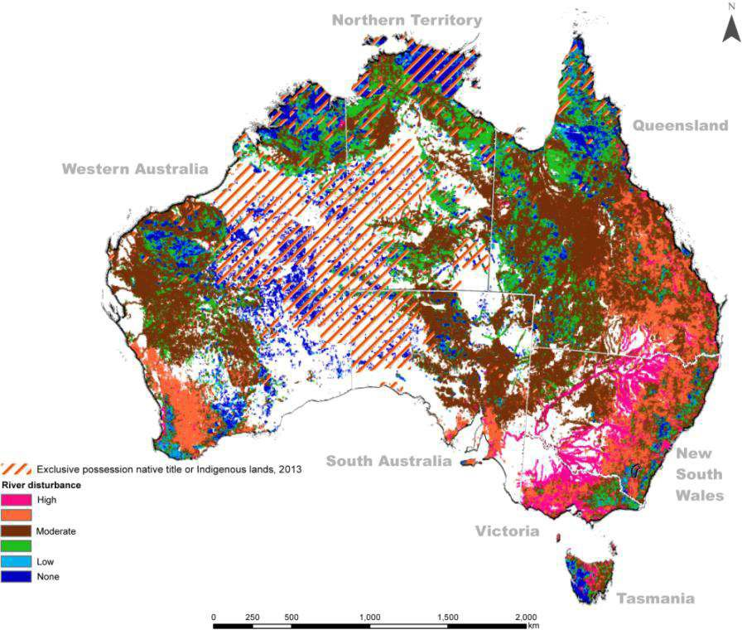Figure 5.10 shows the relationship between exclusive possession native title and Indigenous lands and the riparian zones of rivers, so crucial to biodiversity and water quality. Figure 5.10 shows a high river disturbance indicator in the south east and south west of the continent, especially along the Murray Darling system. Altman (2014:9) notes that while there has been low disturbance in the remote tropical savannah, this does not necessarily suggest these areas are threat free.
Figure 5.10: Disturbance of riparian zones (2008) and exclusive possession native title or Indigenous lands (2013)
Source: Altman 2014:11
Altman notes that because much of the Indigenous estate has high environmental values, it is resulting in more of this land being incorporated into the conservation estate, especially since the mid-1990s when the NRS was created (as discussed in Part 4.2 of Chapter 4 and in Chapter 6). Figure 5.11 shows the extent of the Indigenous estate and national conservation lands in about 2012 when there were only 60 IPAs.

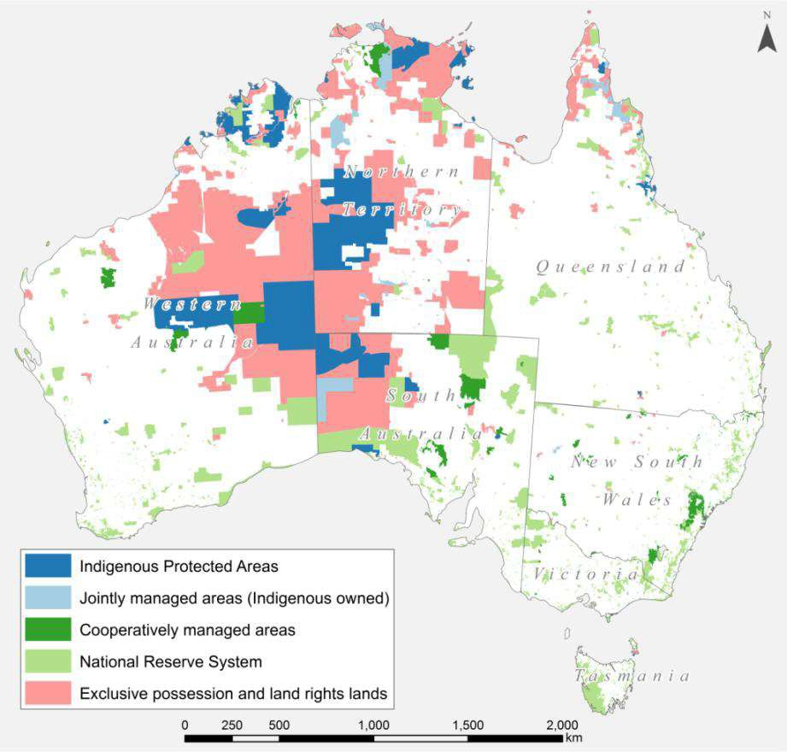

Figure 5.11: The Indigenous estate and national conservation lands
Source: Altman 2014:12
This situation is shown diagrammatically in Figure 5.12. The data used to compile Figure 5.12 was current at 31 December 2013. As discussed in Chapter 4, the NRS and the number of IPAs have increased significantly since then, and there is potential for more to be added, if traditional owners so wish (Altman, 2014:13).
The purpose of Altman’s analysis was to show the correlation between the growing size of the Indigenous estate and its environmental values. Altman’s (2014:1) analysis focuses on the tension between national growth (as measured by gross domestic product dependent on industrial extraction of minerals and commodity exports) and local and regional development for Indigenous landowners. Altman (2014) argues that while the tension is based on a different focus on livelihoods and wellbeing, there is potential for the commodification of the provision of environmental and other ecosystem services on the Indigenous estate.
Furthermore, the Intergovernmental Science-Policy Platform on Biodiversity and Ecosystem Services (IPBES, 2019:14) in its Global Assessment of Biodiversity and Ecosystem Services notes that at least a quarter of the global land area is traditionally owned, managed, used or occupied by Indigenous peoples, and that nature and ecosystems managed by Indigenous peoples and local communities is coming under increasing pressure. The IPBES (2019:14) also reports that among the indicators used by Indigenous peoples and local communities, 72 per cent are showing negative trends that underpin local livelihoods and wellbeing, and that the impacts of climate change are also adversely affecting the ability of Indigenous peoples and local

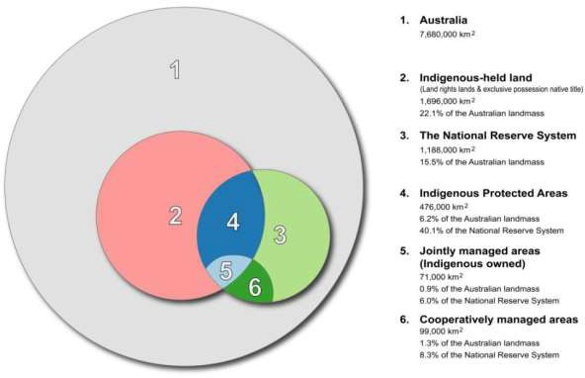communities to conserve and sustainably manage the areas of high biodiversity and conservation value that are also of value to broader society.
Figure 5.12: Indigenous and other components of the terrestrial conservation estate
Source: Altman 2014:13
As discussed in Chapter 4, ABARES prepares a periodic State of the Forests Report (SoFR) which includes as a key indicator (Indicator 6.4a) the area of forest to which Indigenous people have use and rights that protect their special values and which are recognised through formal and informal management regimes (ABARES, 2018:397). ABARES believes that an essential part of forest management is an acceptable level of accountability for the protection of Indigenous peoples’ cultural, religious, social and spiritual needs and values.
In order to report against this indicator, ABARES collates information on land under Indigenous ownership, management or control and groups this information into the following four categories (Dillon et al, 2015):
      - Indigenous owned and managed: freehold land that is both owned and managed by Indigenous persons, entities or organisations.
      - Indigenous managed: land that is managed but not owned by Indigenous people, entities or organisations (e.g. Crown reserves and leases); and lands that are owned by Indigenous people, but have formal shared management agreements with Australian and state and territory government agencies (e.g. leased-back nature conservation reserves).
      - Indigenous co-managed: land that is owned and managed by other parties, but have formal, legally binding agreements in place to include input from Indigenous people in the process of developing and implementing a management plan (e.g. nature conservation reserve memoranda of understanding).
      - Other special rights: land subject to native title determinations (exclusive possession or non- exclusive possession), registered Indigenous Land Use Agreements and legislated special cultural use provisions. These are independent of tenure and, in most cases, do not grant ownership or management rights of land to Indigenous communities. They can provide for the right to access areas of cultural significance or the use of areas for cultural purposes (e.g. within protected water

supply catchment areas), or can provide a legal requirement for consultation with the local Indigenous community before any major development or other activities can take place (ABARES, 2018:398).
SGSEP was able to access the ABARES database on the Indigenous estate and has mapped the selected Indigenous NESP Hub research project locations against each of these four categories of Indigenous land ownership, management or control. Figure 5.13 shows the composite result of the selected NESP Hub research projects against the four Indigenous land ownership, management or control categories. The full suite of maps of each NESP Hub’s selected research projects and the four categories of Indigenous land ownership, management or control are shown in Appendix J.

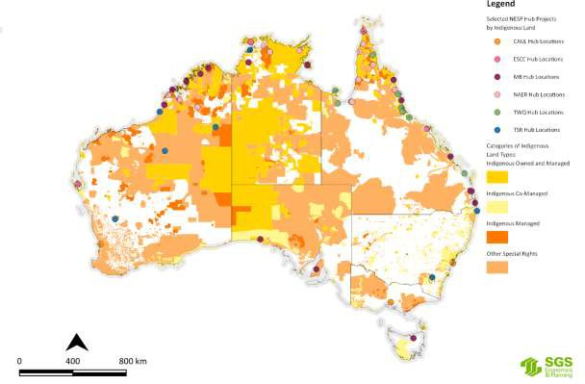
Figure 5.13: Selected NESP Hub Indigenous research projects by Indigenous Land Categories
Source: SGS Economics and Planning utilising NESP Hub data and ABARES Indigenous land data with permission, 2020.
By necessity, the maps focus on the macroscopic and continental scale and are not intended to focus on the local scale. Nevertheless, it is possible to make the observation that there is a reasonable correlation between the location of NESP Hub projects and Indigenous owned and/or managed lands of one kind or another. But having drawn that general observation, SGSEP hastens to add that this is an area where further investigation is required in consultation with the Indigenous people and entities that have interests in land to ascertain with greater clarity what their environmental and climate science research themes and questions may be.
Figure 5.13 shows that several Indigenous research projects are located on or near parts of the Indigenous estate. However, the extent to which the Indigenous land owners or managers are utilising the results of NESP Hub research that has taken place on or near their lands remains to be ascertained with any degree of certainty. One factor that is abundantly clear, is that following a positive native title determination, the exercise of native title rights and interests to undertake land management activities are not always included in the determination. This can significantly impair native title holders from leveraging their native title rights

to undertake land management activities that would ordinarily also benefit Australia more generally (Grace, 2018). Research undertaken by the NAER Hub in the Fitzroy River region in the Kimberley in WA found that several Prescribed Bodies Corporate and native title claimant groups want better integration of Indigenous knowledge and laws with Australian laws and Western science, as the basis for making better land and water management decisions (personal communication, Michael Douglas, March 2020).

Findings and Conclusions
This chapter examined the geo-spatial location of the selected Indigenous research projects of each of the NESP Hubs against a number of thematic layers of geo-spatial information. The object of this exercise was to ascertain where Indigenous research has taken place that might yield research themes and questions, as well as ascertaining how the selected research projects relate to the other geospatial layers of information.
This analysis enables us to draw the following broad findings and conclusions against each of those geospatial layers.
    - State/Territory: On a jurisdictional basis, there are many more research projects with an Indigenous focus in the northern parts of Australia and less focus on the southern and south eastern parts of Australia. This is due to the fact that two of the NESP Hubs are specifically focussed on Northern Australia, and for the NAER Hub in particular (see Table 2.1), explicit research priorities about Indigenous engagement and partnership have driven this focus. Research projects with an Indigenous focus in the southern parts of Australia are confined to the work of the other four NESP Hubs, and are more limited in number. This state and territory analysis also does not capture a number of key NESP projects as they have a national focus. For example, the ESCC Hub’s national Indigenous Climate Dialogue. Notwithstanding, there are considerable gaps in several jurisdictions where research with Indigenous peoples has not been undertaken, for example in South Australia, Tasmania and the ACT. The environmental and climate science research needs of the Indigenous peoples in the southern portions of Australia needs further investigation.
    - Australia’s Marine BioRegions (MB Hub projects only): The analysis shows that the selected MB Hub’s research projects are spread across most of the Marine Park areas in the northern and western areas of Australia in the waters around Tasmania, but none in the waters around South Australia, Victoria and New South Wales. This suggests that there are gaps in NESP marine science research involving Indigenous peoples in the Southern Ocean regions of Australia. The marine science research needs of the Indigenous peoples in the southern portions of Australia needs further investigation.
    - Australia’s Terrestrial BioRegions: The IBRA classifies Australia's landscapes into 89 large geographically distinct bioregions based on common climate, geology, landform, native vegetation and species information. Some of the Bioregions with the highest level of protection (via the NRS) have a high number of selected NESP Hub research projects with an Indigenous focus. However, the reverse is also true: that many unrepresented Bioregions have no or very few NESP Hub research projects with an Indigenous focus. While there is some correlation between the NESP Hubs’ research projects and the IBRA regions, it would be helpful to have a better understanding of Indigenous peoples’ environmental and climate science research needs and particularly how their cultural knowledge may add value to the IBRA and the NRS in areas that are not able to be dedicated as IPAs.
    - NRM Regions: The analysis shows that in many of the NRM Regions there are very low numbers of Indigenous NESP Hub research projects. What this suggests is that there is limited collaboration between Indigenous NRM projects funded under the NLP and Indigenous NESP Hub research activities. The opportunity for greater alignment between the NRM projects involving regional Indigenous communities funded under the NLP and Indigenous environmental and climate science research needs requires further investigation, especially with respect to biodiversity threats,

ecological systems and land management practices. Many NRM organisations, have prepared Indigenous NRM strategies and plans in collaboration with their Indigenous communities and some also have Indigenous Advisors that could help inform work on regional Indigenous research needs resource and land management.
    - Indigenous Protected Areas: There are currently 76 dedicated IPAs in Australia, covering approximately 67 million hectares and accounting for more than 45 per cent of the National Reserve System's total area and there are also 12 more IPA sites currently under consultation. The analysis shows that many of the NESP projects take IPAs into account in their research and use IPA locations as case studies. IPAs are important to Indigenous Australians because the declaration of an IPA is undertaken in consultation with the relevant TOs and a management plan has to be prepared by the entity that will be appointed to manage the IPA before the declaration can be finalised. This means that an IPA Management Plan carries a considerable degree of authenticity about what the TOs see as threats to the place and its values and how a place should be managed and its values protected. IPA Management plans may also identify matters where research is required either to better understand the nature of threats or how to improve monitoring and management techniques to ensure the place continues to protect the values for which the place was dedicated as an IPA. For these reasons we examine the IPA Management Plans in more detail in Chapter 6.
    - The Indigenous estate is divided into four categories as a way of disaggregating the extent of ownership, management or other control that Indigenous people have over the land and in which they have a declared right or interest through land titling and/or other land management arrangements with the state and/or others. This disaggregation has been done by ABARES to meet their needs for the five-yearly Australia’s State of the Forests Report (SoFR). The analysis shows that not all of the NESP Hubs have undertaken research projects on the Indigenous estate, which is more of a reflection of their research focus being away from these locations. For example, none of the CAUL Hub’s research projects related to the Indigenous estate per se, reflecting the CAUL Hub’s
urban research focus on cities. Whereas several of the ESCC Hub’s research projects, while not necessarily location specific, were about national climate systems information, capacity building and engagement generally, and arguably therefore applies to Indigenous peoples where ever they own, manage or control land and waters as part of the Indigenous estate. The analysis also shows that the MB, NAER, TSR and TWQ Hubs undertook several projects across all elements of the Indigenous estate. Arguably, with the continuing growth of the Indigenous estate, especially in the outer regional areas, remote, very remote parts of Australia, there is room for improving the alignment between the Indigenous estate and the environmental and climate science research needs of the Indigenous land owners and/or managers. This is especially significant given large parts of the Indigenous estate has high biodiversity conservation values (Altman, 2014; Altman and Kerins, 2012; Altman, Buchanan and Larsen, 2007).
The analysis in this Chapter shows that it is possible to map the selected NESP Hubs’ research projects against a number of different thematic geospatial layers of information to assess their value in a wider context. It is also possible to draw some very broad conclusions about Indigenous environmental and climate science research needs in these locations, which we discuss in Chapter 8. However, we were not able to identify Indigenous environmental and climate science research priorities for large areas of Australia not covered by this project documentation. This was not possible for several reasons.
    - Firstly, SGSEP selected and were guided by the Hubs to over 100 research projects across the six NESP Hubs with a high level of Indigenous engagement. We examined those projects in considerable detail in a separate Excel spreadsheet, the results of which are presented above and elsewhere in this report.
    - Secondly, in addition to these selected projects, the NESP Hubs have completed several hundreds of research projects across the country that had some level of Indigenous engagement, albeit ranging

from levels 3 to 1 in the Three Category Approach developed by the TWQ Hub and adopted by most of the other NESP Hubs.
    - Thirdly, the hundreds of research projects undertaken by the NESP Hubs extend across a whole raft of projects ranging in size, location, scope, research subject, methods, outputs and outcomes. Some projects concerned particular species of flora, fauna or marine life which may be relevant to a specific locality or extend over very large geographic areas and particular ecosystems or environments. Other projects focussed on developing resources for information, training or techniques for monitoring or managing landscapes or particular environments, presenting difficult challenges for spatial mapping.
    - Fourthly, the NESP Hubs were not required to identify Indigenous environmental or climate science research priorities geographically or thematically and most of the NESP Hub research projects were not initiated by Indigenous peoples as a reflection of their priorities per se, but rather were initiated by other end-users or the research project arose from Hub priorities.
    - Fifthly, as far as SGSEP could establish, there is no existing documentation nationally of what the environmental and climate science research needs and priorities of Indigenous Australians might be. This has not been done before on a national basis across all environments – terrestrial, aquatic and marine.
    - Sixthly, our research is desk-top based and therefore cannot reflect Aboriginal and Torres Strait Islander peoples’ voices about their environmental and climate science research priorities and the extent to which they are being addressed by NESP (or other programs or agencies). While SGSEP was able to conduct several online meetings with Aboriginal and Torres Strait Islander people and organisations in the final phases of this review, more extensive consultations were not possible as the impact of COVID-19 saw many Aboriginal and Torres Strait Islander organisations and communities shut their offices due to social distancing restrictions.
However, the spatial analysis documented in this Chapter has enabled SGSEP to draw some findings about the inter-relationships between the selected Indigenous research projects undertaken by the NESP Hubs and the various thematic geo-spatial layers of information. Our key findings are that there are some states that have no or very few research projects with an Indigenous focus, some marine parks in the southern and eastern parts of Australia have very few or no research projects with an Indigenous focus, and many bioregions (particularly those that are under-represented in the NRS) have no research projects with an Indigenous focus. SGSEP believes there is a need for better alignment between the geospatial themes and the Indigenous land and marine estates and NRM activities that are funded under the NLP, as that may assist with yielding more information about future Indigenous research needs. It is in Australia’s interests to make better use of the Indigenous knowledge about our environment if Australia is to prosper, not only environmentally, but also socially, culturally and economically.

