APPENDIX H: COMMONWEALTH
AGENCIES AND DEPARTMENTS, INDIGENOUS ENGAGEMENT AND RESEARCH PRIORITIES

In the workplan for this Review for comparative and overlap purposes, SGSEP also agreed to gather information relating to Indigenous engagement and environmental and climate science research activities from other related Commonwealth agencies and departments. The agencies and departments included the following:
- The Australian Institute of Marine Science (AIMS)
- The Bureau of Meteorology (BoM)
- The Commonwealth Scientific and Industrial Research Organisation (CSIRO)
- Geoscience Australia
- The Great Barrier Reef Marine Park Authority (GBRMPA)
- The Murray Darling Basin Authority MDBA)
- The Torres Strait Regional Authority (TSRA) (noting that is also constitutes one of the NRM regions)
- The Department of Prime Minister and Cabinet and the National Indigenous Australians Agency (NIAA) and
- The Department of Agriculture, Water and the Environment (DAWE).
SGSEP prepared separate overviews of each agency’s activities, their Indigenous engagement policies and approaches and research activities. These overviews were shared with the respective agency or department for accuracy.
The following provides a brief overview of each Agency’s / Department’s roles and functions, Indigenous engagement and research priorities. More detailed information can be found in the Overviews of each Agency or Department, provided to the Department as separate documents in response to the brief for this Review.

Australian Institute of Marine Science (AIMS)
The Australian Institute of Marine Science (AIMS) is a Commonwealth statutory authority established under the Australian Institute of Marine Science Act 1972 (Cth) and reports to the Minister for Industry. The Institute was established in recognition of a national need to know more about Australia’s marine resources and to provide research assisting those who manage Australia’s marine environment. AIMS provides marine scientific and technological research in support of the protection of Australia’s marine environment and the sustainable use of its wealth for the benefit of all Australians.
Figure H.1 shows the extent of Australia’s marine estate. Australia’s marine territory is the third largest on Earth.

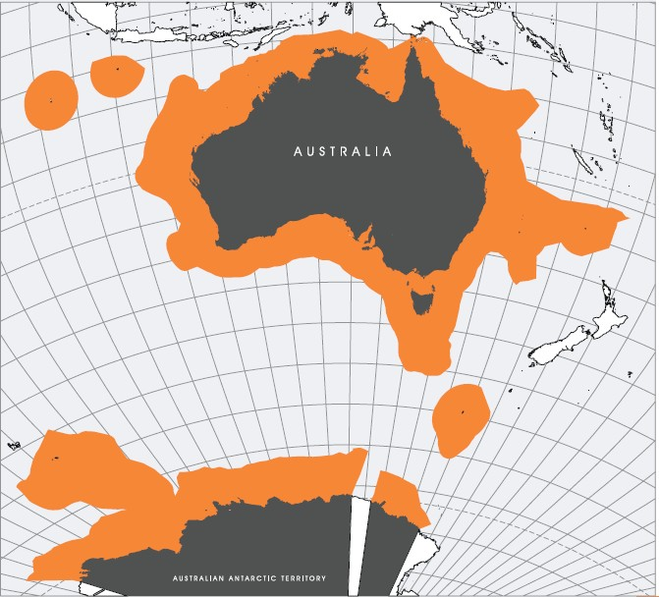
Figure H.1 Australia’s Marine Estate
Source: AIMS Strategic Plan 2015-25, 2015:7.

AIMS’ mission is to deliver the science to help realise three key long-term impacts for Australia:
- Improve the health and resilience of marine and coastal ecosystems across northern Australia.
- Create economic, social and environmental net benefits for marine industries and coastal communities.
- Protect coral reefs and other tropical marine environments from the effects of climate change.

Indigenous Engagement
AIMS has adopted an Indigenous Engagement Strategy which commits the agency to working with Indigenous Australians by building its internal cultural competence and meaningful partnerships with Traditional Owners of sea Country in northern Australia; to creating shared research that integrates Indigenous knowledge of sea Country with other sciences; to creating new insights into Australia’s marine systems (as conditions and circumstances allow) and to delivering impactful research for both Indigenous and non-Indigenous Australians.
In relation to Indigenous engagement, AIMS’ vision is to meaningfully engage with Aboriginal and Torres
Strait Islander peoples in order to build reciprocal capacity – through mutually beneficial research – that

will support the sustainable management of land and sea Country for future generations. The Institute’s
vision will be achieved through the following goals:
- Incorporate Indigenous perspectives into the way AIMS does business - and ensure ongoing commitment to the implementation of the Aboriginal and Torres Strait Islander Engagement Strategy.
- Improve the cultural awareness of AIMS staff through opportunities to better understand Indigenous culture – and demonstrate respect and recognition of Aboriginal and Torres Strait Islander people and their culture when working with them.
- Establish and foster strong mutually beneficial working relationships with Traditional Owners and key representative organisations – appropriate to AIMS’ work.
- Improve the marine science outcomes for AIMS, and Indigenous Land and Sea Managers, through stronger partnerships that incorporate the extraordinary contributions of Aboriginal and Torres Strait Islander people.
- Contribute to the training and development of Aboriginal and Torres Strait Islander people in marine science – leading to career pathways at AIMS and other organisations.
AIMS’ Indigenous Engagement Strategy is assessed against a detailed plan of action with identified tasks,
responsibilities and timelines.

Research Snapshot
The National Marine Science Research Plan 2015-2025
The National Marine Science Research Plan 2015-2025 (AIMS 2015) was developed in response to the 2013 position paper Marine Nation 2025: Marine Science to Support Australia’s Blue Economy.³ The Plan begins with an Indigenous perspective of Sea Country by Rodney Dillon, the National Sea Rights Portfolio Commissioner:
“Our culture and our view of oceans aren’t fixed in time. They aren’t held in an institution. They don’t hang upon a museum wall. You won’t find them searching the texts of the many scientists that have studied our people’s ways. Oceans are a part of us, and we are a part of them.”
The Plan outlines seven interconnected grand challenges facing Australia and the marine science needed to address them. The grand challenges are:
- marine sovereignty, security and safety
- energy security
- food security
- biodiversity, conservation and ecosystem health
- urban coastal environments
- climate variability and change
- resource allocation.
The primary focus of AIMS’ research is to support a resilient Great Barrier Reef, sustainable coastal ecosystems and industries across northern Australia, including environmentally sustainable offshore oil and gas development on Australia’s North-West Shelf. AIMS’ research priorities include:
- Cumulative impacts and ecosystem resilience. Understanding the cumulative impacts of global and local pressures on tropical marine ecosystems.
- Marine and coastal industries. Supporting the sustainable development of Australia’s marine and
coastal industries through partnership and innovation.
- Measuring change. Supporting conservation and sustainable use in tropical marine environments.

3 Oceans Policy Science Advisory Group (2013), Marine Nation 2025: Marine Science to Support Australia’s Blue Economy, Australian Government, Canberra.

- Reef recovery, adaptation and restoration. Enhancing the evolutionary potential and climate resilience of coral reefs for conservation and management.
- Species at risk. Identifying important habitats and threats to iconic marine species.
- Technology development and innovation. Information, monitoring and decision-making tools to help managers meet the challenges of sustainable ocean use.
AIMS’ current research programs⁴ include:
- A healthy and resilient Great Barrier Reef. The Great Barrier Reef program conducts interdisciplinary research to provide managers and policymakers with a better understanding of the Reef’s vulnerability to climate change and ocean acidification, and its interactions with local and regional environmental stressors. The program’s strategic objectives are to:
  - Develop a framework for understanding cumulative stressors and critical thresholds.
  - Determine adaptive capacity of key functional groups, and new opportunities for managing goods and services under climate change.
  - Produce a new comprehensive status and trends reporting system for the Great Barrier Reef World Heritage Area (GBRWHA).
  - Produce a comprehensive status and trends report for fish and benthos on the GBRWHA.
- Sustainable coastal ecosystems and industries in tropical Australia. The coastal program delivers science relating to the critical issue of cumulative stressors in a broad range of tropical marine habitats arising from coastal and catchment development, in the context of shelf-scale ecosystem drivers. The program’s strategic objectives are to:
  - Develop strategic research and effective solutions for the management and control of crown-of-thorns (CoTS) starfish.
  - Assess the resilience of GBR inshore ecosystems in response to water quality.
  - Develop regional models of coastal environmental condition and function.
  - Determine the impacts of known and emerging contaminants.
  - Identify zones of influence of and biological responses to dredging activities.
- Sustainable use of north-west marine ecosystems. This program focuses on the sustainable development of marine resources in north-west Australia. The program’s strategic objectives are to:
  - Determine impacts of known and emerging contaminants.
  - Design of a regional assessment and monitoring plan and gap analysis tool for NW Australia.
  - Develop and test a predictive model of benthic communities on reefs and shoals.
  - Region-wide analysis of fauna abundance, distribution and critical areas with a focus on breeding, nesting, calving grounds and nursery areas.
- Data and technology innovation. This program provides the interface between science and infrastructure management, and in some cases science and users. The program’s strategic objectives are to:
  - Produce structured decision-support tools to link risk analyses, monitoring, modelling and adaptive management.
  - Expand the range of autonomous and automated observing and assessment methods throughout tropical marine Australia.
  - Build improved and more efficient data and image analysis pipelines that are routinely used to distribute knowledge to users.

4 https://www.aims.gov.au/research/research-programs

  - Single scalable and modular eAtlas platform that users can adopt as regional atlases specific to their needs.
More specifically, AIMS’ National Marine Science Research Plan 2015-2025 acknowledges that
- Indigenous Australians can play an increasing role in marine research and monitoring;
- recognition of their cultural connection with the oceans around Australia; and
- increasing opportunities for collaboration between Indigenous and Western knowledge systems.
This is reflected in several places throughout the Plan. The following are some of the more pertinent statements in the Plan about Indigenous Australians:
- But you can’t put a price tag on the priceless, with a coast-hugging population and a nation of beachgoers, sailors, surfers, fishers and Indigenous people placing great emphasis on the cultural and aesthetic value of our oceans. (AIMS, 2015:7).

- The ‘North’ is also home to Australia’s iconic coral reef and mangrove systems, major fisheries and a multibillion-dollar tourism sector. ‘Sea countries’ are also the spiritual and cultural heart of Indigenous people across this northern marine region, and all around Australia’s coastlines, where they seek to be acknowledged as custodians and marine managers. (AIMS 2015:10).
- Significant opportunities also exist for Indigenous, social and economic benefit from improved access to marine resources. (AIMS, 2015:19).

- Around 85 per cent of the population live within 50 kilometres of the coast, which is also home to port development; oil, gas and mineral resources; tourism and recreation; Indigenous communities; shipping and transport; new marine industries; fishing industry; renewable energy; and water and food security. (AIMS, 2015:22)

- The challenge. Coastal and marine developments are increasingly the scenes for heated competition between a broad range of users, including different industry sectors, conservation groups, marine park stakeholders, recreational and Indigenous users, and the general public. This competition often involves high-profile, professional and expensive campaigns based on inherently different values. The polarity in this debate intensifies where profound uncertainty exists on the nature and extent of risks to environmental and social values, and how these are best mitigated. Similarly, conflict is common where property rights are inadequately defined. (AIMS, 2015:24).

- Local, state and Commonwealth authorities could also improve the routine collection of social and economic data to develop a national baseline on marine communities and industries. The integration of local Indigenous knowledge could also support the development of this baseline. The first Australians have developed an in-depth understanding of coastal marine systems, capturing knowledge about system function and change over the past 40,000 years. This understanding informs traditional aquatic resource management systems, and there is increasing recognition of this knowledge base and the benefits of its integration with western knowledge. (AIMS, 2015:26).

- Furthermore, there is a growing recognition of the role that Indigenous knowledge can play in marine science and research. Indigenous Australians are becoming increasingly involved in aquatic research and monitoring, with ranger programs supporting ground-level management and cross collaboration between Indigenous and western knowledge. Commitment from state and Commonwealth governments has supported Indigenous involvement in fisheries and aquaculture, and increased the broader recognition of Indigenous Australians as active leaders in marine research. (AIMS, 2015:27).

- Policymakers, regulators and industries, who are involved in stewardship of Australia’s marine jurisdiction, face complex challenges. They have to account for the multiple risks and impacts from agricultural and industrial development, invasive species, climate change, population growth, coastal urban expansion and changing social attitudes. They also need to take into account strong cultural beliefs, such as Indigenous rights. (AIMS, 2015:28).
The National Marine Science Research Plan also includes eight (8) recommendations, however none of them relate specifically to the environmental or climate science research themes or questions that may be of interest or concern to Aboriginal and Torres Strait Islander peoples.

Bureau of Meteorology (BoM)
The Bureau of Meteorology is Australia's national weather, climate and water agency. The Bureau operates under the authority of the Meteorology Act 1955 (Cth) and the Water Act 2007 (Cth) which provide the legal basis for its activities, while its operation is continually assessed in accordance with the national need for climatic records, water information, scientific understanding of Australian weather and climate and effective service provision to the Australian community. The Bureau of Meteorology is also obliged to fulfil Australia's international obligations under the Convention of the World Meteorological Organization (WMO) and related international meteorological treaties and agreements.
The Bureau’s expertise and services assist Australians in dealing with the harsh realities of their natural environment, including drought, floods, fires, storms, tsunami and tropical cyclones. Through regular forecasts, warnings, monitoring and advice spanning the Australian region and Antarctic territory, the Bureau provides one of the most fundamental and widely used services of government.
The Bureau contributes to national social, economic, cultural and environmental goals by providing observational, meteorological, hydrological and oceanographic services and by undertaking research into science and environment related issues in support of its operations and services.

Indigenous Engagement
The Bureau of Meteorology has developed a Reconciliation Action Plan November 2016–2019. (BoM, 2016) which aims to create respectful relationships and sustainable opportunities between Aboriginal and Torres Strait Islanders and other Australians and helps achieve the Bureau’s Strategic Plan 2015–2020 objectives.
For the Bureau, reconciliation means meaningful engagement with Aboriginal and Torres Strait Islander people—whether as users of Bureau products and services, or otherwise contributing to or sharing knowledge with the Bureau. Central to this intent is striving to understand, then harness and celebrate the unique skills and perspectives of Aboriginal and Torres Strait Islander people. Through the Indigenous Weather Knowledge website, the Bureau is working with communities that wish to record and share valuable seasonal and environmental information and traditional knowledge.
Key initiatives arising from the Reconciliation Action Plan include:
- the Indigenous Careers Program, which aims to increase employment opportunities through the recruitment of cadets and graduates; and
- Indigenous Weather Knowledge, the online platform providing education about, and preservation of, Australia’s Indigenous peoples' relationships with the environment, weather and climate.

Research Snapshot
The Bureau of Meteorology has developed an Indigenous Weather Knowledge website,⁵ launched in 2002 as a joint partnership between the Bureau, the former Aboriginal and Torres Strait Islander Commission

5 http://www.bom.gov.au/iwk/index.shtml

(ATSIC) and Monash University's Centre for Indigenous Studies. The website is a formal recognition of traditional weather and climate knowledge that has been developed and passed down through countless generations by Aboriginal and Torres Strait Islander people.
The Bureau has also developed a website devoted to Indigenous Language, Culture and Environmental Knowledge, to aid learning about the history of Indigenous weather, season and environment knowledge across Australia. The webpage includes links to 16 different cultural groups and their annual climate cycles.⁶

Commonwealth Scientific and Industrial Research Organisation (CSIRO)
The Commonwealth Scientific and Industrial Research Organisation (CSIRO) is an Australian Government corporate entity, established under the provisions of the Science and Industry Research Act 1949 (Cth). The Act sets out the CSIRO’s functions and powers, as well as those of its Minister, Board and Chief Executive.
The CSIRO’s primary functions are:
- To carry out scientific research for any of the following purposes:
  - Assisting Australian industry;
  - Furthering the interests of the Australian community;
  - Contributing to the achievement of Australian national objectives or the performance of the national and international responsibilities of the Commonwealth; and
  - Any other purpose determined by the Minister;
- To encourage or facilitate the application or utilisation of the results of such research.
The CSIRO’s secondary functions include international scientific liaison, training of research workers, publication of research results, technology transfer of other research, provision of scientific services and dissemination of information about science and technology.

Indigenous Engagement
CSIRO believes that Aboriginal and Torres Strait Islander peoples have extraordinary contributions to make to Australia across cultural, economic and scientific domains and the organisation has an Indigenous Engagement Strategy (CSIRO, 2007) and Reconciliation Action Plan (CSIRO, 2018).
CSIRO initiated its Indigenous Engagement Strategy in July 2007 with the key pillars of the Strategy (science, employment, education, learning) now covered and implemented through the CSIRO Reconciliation Action Plan (RAP).
CSIRO’s second RAP aims to strengthen its approach to driving reconciliation through its business activities, services and programs, and develop mutually beneficial relationships with Aboriginal and Torres Strait Islander stakeholders and commits CSIRO to continue fostering a culture of inclusion and cultural awareness. CSIRO's RAP:
- affirms CSIRO’s commitment to reconciliation with Aboriginal and Torres Strait Islander peoples, the oldest living culture in the world;
- recognises Aboriginal and Torres Strait Islander peoples as the first inhabitants of Australia and respects their enduring connection to lands, skies, waters, plants and animals;
- commits to enabling Aboriginal and Torres Strait Islander peoples to contribute to and benefit from education, science, innovation and research;
- demonstrates CSIRO's commitment to fostering a culture of inclusion and cultural awareness;

6 http://www.bom.gov.au/iwk/culture.shtml

- demonstrates that CSIRO is contributing towards the Commonwealth Government's target of three per cent of all purchases being made through Aboriginal and Torres Strait Islander owned businesses;
- commits to the Commonwealth Government’s target of three per cent Aboriginal and Torres Strait Islander employment and outlines a new Aboriginal and Torres Strait Islander Employment Strategy to help CSIRO achieve this;
- commits to celebrating the successes of Aboriginal and Torres Strait Islander peoples and the sharing of their customs, cultures, knowledge and languages to improve CSIRO’s work for the benefit of the Australian community.
A key science related action within the CSIRO RAP is:
Action 5 – Opportunities: Increase Indigenous-led, driven and/or co-developed research activities in areas that address aspirations, opportunities and challenges prioritised by Aboriginal and Torres Strait Islander people, communities and organisations.
CSIRO’s RAP is championed by an internal committee, the Indigenous Engagement Implementation Committee, and the external Indigenous Strategic Advisory Council.
The Indigenous Engagement Implementation Committee (IEIC), reports to a member of CSIRO’s Executive Team who has responsibility for CSIRO’s Indigenous engagement activities and is a member of the IEIC together with the CSIRO Office of Indigenous Engagement and representatives across all CSIRO Business units and enterprise service areas.
CSIRO external Indigenous Strategic Advisory Council (ISAC) operates under CSIRO’s Advisory Committee Terms of Reference and reports to CSIRO’s Board via the CSIRO Executive Team. The ISAC provides strategic advice to CSIRO, in relation to framing its aspirations, policies and actions relating to its Indigenous Engagement Strategy.
As outlined by the Chief Executive, Larry Marshal, CSIRO’s RAP indicates CSIRO’s commitment to investing in the establishment of an Indigenous Science Program “spanning all research domains within the organisation. The program will be a unified, Indigenous-led program, based on a co-developed Indigenous science agenda to tackle national challenges prioritised by Indigenous Australians, address new science opportunities and undertake cutting edge science by and with Aboriginal and Torres Strait Islander peoples.”
CSIRO has also instigated other initiatives that aimed at raising the profile of Indigenous involvement in scientific research. These include:
- Indigenous STEM Education Project;
- Young Indigenous Women’s STEM Academy;
- Jack Cusack Memorial Lecture.

Research Snapshot
Indigenous Science Program
During 2018-2019 CSIRO undertook an Indigenous Science Program scoping project to co-develop with Indigenous leaders an internal investment case to the organisation for a CSIRO-wide Indigenous Science Program (ISP). The scoping project team included two Indigenous researchers as the science co-leads (Dr Leah Talbot and Dr Cass Hunter) and brought together an Independent Indigenous Reference Group with a CSIRO Reference Group. An outcome of the investment case is to set up an Indigenous Science and Engagement (ISE) team and recruitment of an ISE Director.
The Indigenous Science Program (ISP) will be a whole of organisation initiative to deliver:
- Science solutions prioritised by Indigenous Australia;

- Pathways that embrace co-development in how we deliver our science;
- Talent that is inspired and equipped to make a difference for the nation.
Indigenous knowledge and science also represents a cross-cutting capability within CSIRO’s Future Science & Technology plan which is an internal strategy with a forward decadal time span to provide strategy and planning guidance to inform CSIRO science and technology capabilities.
Key areas of Indigenous science capability
Practices CSIRO uses to engage with Indigenous interests in research in the design, implementation and translation of outcomes of research projects
CSIRO engages Indigenous people in the co-design, implementation and translation of outcomes of research projects through diverse range of approaches, including participatory action research, weaving Indigenous, scientific and local knowledge, photovoice, collaborative film production, participatory mapping, matrices and guides that identify cultural law risks, and the “Walking-Together” Indigenist research approach: research as a respectful, reciprocal exchange between Indigenous peoples involving five steps.
CSIRO protects Indigenous intellectual and cultural rights in its research projects through arrangements that ensure ownership remains with Traditional Owners. All CSIRO research with and for Indigenous Australians complies with the National Statement on Ethical Conduct in Human Research (NHMRC et al, 2018a) and follows requirements for Free Prior and Informed Consent and mutual benefit sharing.
Mechanisms currently in use include:
- Steering Groups with a majority of Indigenous Peoples;
- Indigenous Peoples as co-authors on publications;
- Research Agreements and MOUs with Indigenous Organisations; and
- Oversight by the CSIRO Social Science and Human Research Ethics Committee containing Indigenous community representatives.
CSIRO is also developing an Indigenous Cultural and Intellectual Property (ICIP) policy and protocols to guide organisational responses in operating at the cultural interface between IP and ICIP.
Activating the economic value of land, water, sea and cultural resource rights
CSIRO is engaged in substantial research aimed at the development of new Indigenous enterprises and economies based on land, water and sea that have a sustainable social and environmental bottom line/benefit. Key application domains include:
- Fire management for carbon and protocols for Indigenous fire partnerships;
- Environmental and ecosystem services;
- Biosecurity and feral animals;
- Ecotourism;
- Blue economy;
- Bush food development;
- Pastoral improvement/transition;
- Evaluating investment in in Indigenous cultural and natural resource management (ICNRM) to identify multiple co-benefits, enhance new income streams, help close the gap, and generate pathways to economic independence; and
- Understanding non-government investment in ICNRM enterprises, including philanthropic and impact investors.
CSIRO science and enterprise projects support Indigenous-led planning and prospectus development to secure effective strategy and governance, engage external supporters, and attract new investment. They also align with national and international environmental and sustainable development agendas which are

now incorporating Indigenous voice (for example NESP, Intergovernmental Panel for Biodiversity and Ecosystem Sciences (IPBES, 2019), and the UN Sustainable Development Goals (UN, 2015).
Creating jobs, fostering labour participation, entrepreneurship and business acumen
An Indigenous Innovation Alliance established in 2018-2019 between CSIRO, University of Queensland and Charles Darwin University supported Indigenous-led approaches to test and co-design business development models and methods. Innovative technical and community solutions that positively respond to Indigenous priorities for their land and sea estates were developed and tested.
Examples of collaboration with the NESP Hubs
While CSIRO hosts the Earth Sciences and Climate Change (ESCC) Hub funded under NESP, many of CSIRO’s scientists are also engaged in several research projects initiated by the other NESP Hubs. The following are just a very small selection of NESP Hub projects where CSIRO scientists have played active and key roles.
- Bininj/Mungguy indicators for healthy country Project. Through the NAER Hub, CSIRO was involved in the developing and trialling an adaptive approach to co-management using Bininj/Mungguy indicators to monitor and evaluate the health of important values on Country. (NAER Hub Project No. 5.5 Phase 2)
- Protocols for Indigenous fire-management. Through the NAER Hub, CSIRO was involved in the development of a series of protocols to guide Indigenous fire management partners delivering environmental and cultural management programs.7 (NAER Hub Project 5.2)
- Managing threatened species and their habitats. Through the TSR Hub CSIRO collaborated with Indigenous people to support on-Country opportunities for protecting and recovering Australia's threatened species and their habitats.8 (TSR Hub Project No. 6.2)
- Research priorities for Indigenous Protected Areas (IPAs). Through the NAER Hub, CSIRO collaborated in an assessment of the research priorities for IPAs in northern Australia and identifying the environmental, social, economic and cultural benefits associated with IPAs.9 (NAER Hub Project No. 5.1)
- Investing in Indigenous cultural & natural resource managers. Through the NAER Hub, using Indigenous led and co-developed participatory methods, focused on three key investor types – Indigenous corporations and communities, shareholder corporations, and philanthropic investors
– to help investment in the ICNRM sector continue to expand and diversify into the future.10 (NAER Hub project No. 5.6)

Geoscience Australia
Geoscience Australia (GA) is the national public sector geoscience organisation. GA’s mission is to be the trusted source of information on Australia’s geology and geography for government, industry and community decision making. GA applies science and technology to describe and understand the geology and geography of Australia. The Agency’s work covers the Australian landmass, Australian marine jurisdiction and responsible jurisdictions in Antarctica. This requires navigating complex legislative frameworks and building trusted relationships with stakeholders.
GA has responsibility for meeting the Australian Government's geoscience requirements. This role takes the Agency beyond its historic focus on resource development to topics as diverse as natural hazards, such as tsunami and earthquakes, environmental issues, including the impacts of climate change, groundwater research, marine and coastal research, carbon capture and storage and vegetation monitoring as well as

7 https://www.nespnorthern.edu.au/2016/10/11/developing-protocols-indigenous-fire-management-partnerships/
8 http://www.nespthreatenedspecies.edu.au/projects/collaborations-with-indigenous-people-in-threatened-species- research-and-management
9 https://www.nespnorthern.edu.au/projects/nesp/research-priorities-for-ipas-across-northern-australia/
10 https://www.nespnorthern.edu.au/projects/nesp/guided-resource-investment/

Earth observations from space. Geoscience Australia's remit also extends beyond the Australian landmass to Australia's vast marine jurisdiction.
GA’s work aligns with the national science and research priorities and supports global and domestic government initiatives and impacts six key areas of society:
- Maximising the value from our abundant mineral and energy resources;
- Strengthening our resilience to the impact of hazards;
- Optimising and sustaining our water use;
- Supporting the sustainable use of our marine environment;
- Using digital mapping for faster and smarter decision making; and
- Equipping government, industry and the community with geoscience data, and information to make informed decisions.
GA’s Strategic Plan 2028, commits GA to delivering data and advice that helps government, industry and the community to address challenges and enhance opportunities facing Australia now and into the future. In doing so, GA also commits to respect and collaborate with the First Peoples—Australia’s original mappers, miners and navigators (GA 2018).

Current Indigenous Engagement
The work undertaken by GA is biological in essence, in that GA observes the earth and its functions. However, in order to perform much of its observations, researchers from Geoscience Australia must access land, including land that is owned or managed by TOs and Aboriginal and Torres Strait Islander community organisations. Access to such land is governed by a series of policies, procedures and guidelines including the following:
- Cultural heritage legislation: Indigenous and Non-Indigenous Guidelines;
- Environmental Legislation Guidelines;
- Fieldwork: Information for stakeholders- land access and cultural heritage considerations;
- Landholder relationship management guidelines;
- Identifying land tenure guidelines;
- Land access and cultural heritage policy;
- Land access and cultural heritage procedures.¹¹
The current level of engagement between GA and stakeholders depends on the type of activity being undertaken, the degree to which the land would be disturbed and the type of stakeholder involved. GA uses four levels of engagement: notify, consult, involve and collaborate. For example, an aerial survey with no ground disturbance requires notification only to the affected stakeholders. However, stakeholders are encouraged to express concerns and ask questions. Additional consultation is undertaken on a case-by- case basis and tailored to specific needs. GA’s Strategic Plan notes that it will maintain a focus on the needs of its stakeholders, including respectfully engaging and collaborating with Aboriginal and Torres Strait Islander peoples.

Future Indigenous Engagement
GA has adopted a Land and Marine Access (LAMA) Strategy 2020 which provides for an Indigenous Stakeholder Engagement Strategy. The LAMA Indigenous Engagement Strategy 2020 sets out to develop trusted, mutually beneficial relationships and collaborations with Indigenous stakeholders through the application of best-practice engagement protocols. The UN Declaration on the Rights of Indigenous Peoples (UN 2007) and the UN 2030 Agenda for Sustainable Development (UN 2015) are used to inform the LAMA Indigenous Engagement Strategy. The Indigenous Engagement Strategy aims to continue to build and strengthen relationships with Aboriginal and Torres Strait Islander groups and communities, develop trusted relationships with mutual benefit. The Strategy includes several objectives and several

11 See GA’s Corporate Documents: https://www.ga.gov.au/about/corporate-documents

short and long-term indicators for measuring its success. The Strategy also includes a commitment to collaborating with other federal and state agencies by sharing knowledge and resources which are likely to lead to more integrated outcomes and mitigate the risk of ‘engagement fatigue’ that might result amongst GA’s key Indigenous stakeholders.
GA has identified two issues in relation to its efforts to meaningfully engage with Aboriginal and Torres Strait Islander communities and TOs, and they are obtaining true consent to access land and assets, and data access disadvantage. Aboriginal and Torres Strait Islander peoples have expressed much frustration over these matters to GA, and they have been acknowledged by GA.
Given the concerns expressed by Aboriginal and Torres Strait Islander peoples, GA is in the process of placing much greater effort in moving to a more formal approach to managing marine and land access. GA has therefore committed to ensuring meaningful engagement with Aboriginal and Torres Strait Islander stakeholders through free, prior and informed consent.¹² In working towards these goals, GA is striving to engage early with traditional owners of land where surveys are being conducted, allowing sufficient time for relationships of trust to be developed.
GA has recently undertaken two projects where different engagement approaches were utilised. The approaches are outlined in a published paper (Mouthaan, Buchanan and Sweeney, 2020). Mouthaan, Buchanan and Sweeney (2020) set out the land access process GA undertook in two projects in Northern Australia; one project focused on broad scale, low-impact field activities associated with the AusAEM survey (airborne electromagnetic survey); and the other project focused on Indigenous engagement in relation to the Barkly Seismic Survey in the NT.
GA notes the following key learnings from these projects:
- Traditional decision-making and stakeholder consultation processes were not broad enough to provide the necessary information and to develop a level of trust with all interested stakeholders.
- In order to develop trust, GA’s project governance now includes a consideration of impacts and benefits of field activities and data acquisition programs for all stakeholders and not just landholders.
- GA has learnt the value of data to Indigenous stakeholders, providing them with the information being sought by industry has created new opportunities for early conversations about future land use and opportunities to explore GA’s data portal, provide feedback and learn about how GA’s data is used (Mouthaan, Buchanan and Sweeney 2020).
One of the critical lessons learned from the AusAEM study was that while the survey involved no ground disturbance or ‘boots on the ground’, landholders and Aboriginal custodians were advised of the flight paths and schedules for low flying survey planes prior to them occurring in order to minimise impacts. Flight schedules were often amended after requests were received from landholders who were undertaking mustering and other activities that could be disrupted by the survey. A request from the Manta Rirrtinya people of the Gibson Desert Area to be mindful of the emu hatching season resulted in revision of the data acquisition sequence (Mouthaan, Buchanan and Sweeney, 2020).
GA is also committed to delivering quality data to a broader cross-section of society through modern data platforms. As an Australian Government agency, GA’s primary stakeholders and collaborators include state and territory agencies, industry and Indigenous peoples and communities. GA actively supports Indigenous communities to access GA’s data through a number of initiatives, including the development of a community/education portal that supports users to gain greater understanding of the data, its limits, and potential uses.

12 Free, prior and informed consent is a specific right that pertains to Indigenous peoples and is recognised in several articles in the United Nations Declaration on the Rights of Indigenous Peoples (UN 2007).

Great Barrier Reef Marine Park Authority (GBRMPA)
The Great Barrier Reef Marine Park Authority (GBRMPA) is established under the Great Barrier Reef Marine Park Act 1975 (Cth) (Marine Park Act) and is the Australian Government statutory authority responsible for protecting and managing the environment, biodiversity and heritage values of the Great Barrier Reef Region, one of the world’s premier natural resources.
Figure H.2 shows the extent of the Great Barrier Reef and the Marine Park Boundary. The differences between the Great Barrier Reef Marine Park, the Region, World Heritage Area and Catchment are shown in Figure H.3. The differences between the jurisdictional boundaries are depicted in Figure H.4.
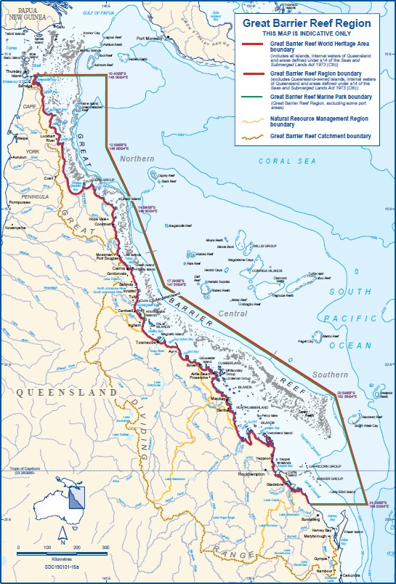
Figure H.2 The Great Barrier Reef and relevant Boundaries
Source: GBRMPA 2019.

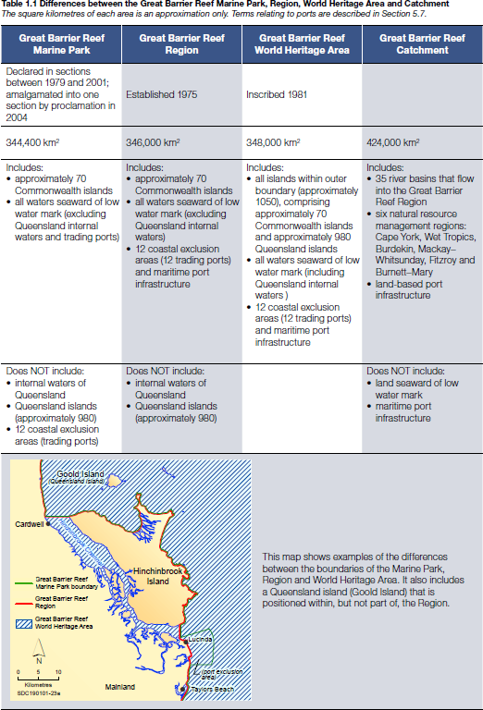
Figure H.3 Differences between the Great Barrier Reef Marine Park, the Region, World Heritage Area and Catchment
Source: GBRMPA 2019.

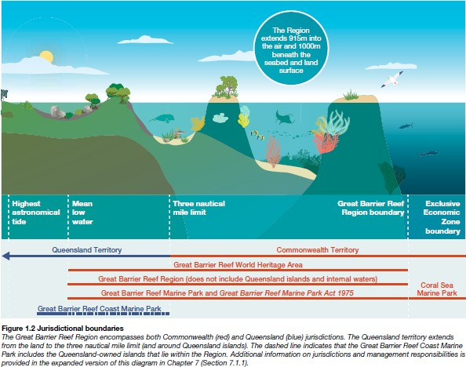Figure H.4 Jurisdictional boundaries on the Great Barrier Reef
Source: GBRMPA 2019:6.

The GBRMPA is responsible for the preparation of several primary documents, including:
- the Reef 2050 Long-Term Sustainability Plan
- the Great Barrier Reef Blueprint for Resilience, and
- the GBR Outlook Report 2019.

Reef 2050 Long-Term Sustainability Plan
In 2015, the Australian and Queensland governments released the Reef 2050 Long-Term Sustainability Plan. The Reef 2050 Plan responds to the World Heritage Committee’s recommendation that Australia develop a long-term plan for sustainable development to protect the Outstanding Universal Value of the Reef.
Since the Plan was released in 2015, the Reef has been deeply impacted by unprecedented climate driven mass coral bleaching events in 2016 and 2017 and severe Tropical Cyclone Debbie in 2017. In light of these events the Great Barrier Reef Ministerial Forum brought forward the scheduled mid-term review of the Plan to ensure it addresses current pressures and remains effective. The updated Plan is the result of the mid-term review.
In addition to the Outlook Report 2014 and the comprehensive two-year strategic assessment of the region — the most complex and comprehensive analysis of environmental management arrangements ever undertaken in Australia – the updated Plan is informed by:

- the Great Barrier Reef Marine Park Authority’s Great Barrier Reef Blueprint for Resilience;
- the Reef 2050 Plan Review Options report, prepared by a consortium of experts;
- advice provided by the Reef 2050 Advisory Bodies, the Reef 2050 Plan Independent Expert Panel and the Reef 2050 Advisory Committee.
In 2018, the Australian Government released the revised Reef 2050 Long-Term Sustainability Plan, July 2018 (Commonwealth of Australia, 2018a). With input from scientists, communities, Traditional Owners, industry and non-government organisations, a key principle of the revised Plan is developing Reef resilience in the face of a variable and changing climate. By improving water quality, maintaining biodiversity and ensuring port development and shipping have minimal impact on the Reef, GBRMPA is targeting activities over which GBRMPA has most control.
All actions in the original Plan were reviewed and have been finalised, updated, recategorised or incorporated in new actions. A comprehensive list of how all actions in the original Plan have been treated is available in the Reef 2050 Long-Term Sustainability Plan - Action Tracker.¹³

Great Barrier Reef Blueprint for Resilience
The Reef Blueprint for Resilience is the primary output of the 2017 Reef Summit, attended by 70 regional, national and international delegates representing marine park managers, Traditional Owners, government agencies, research institutions, industry groups, Reef users and other stakeholders. The Blueprint signals the actions that the GBRMPA will take with its partners to strengthen the Reef’s resilience, its capacity to recover after disturbances and return to a healthy state and the challenges it faces now and in the future.
The Blueprint commits the GBRMPA to, among many other actions, to scaling up research efforts to develop new and more efficient methods for Crown-Of-Thorns surveillance and control, supporting establishment of a research program on large-scale restoration methods, and active localised restoration (with science and research partners) (GBRMPA, 2017).
Indigenous Engagement
Aboriginal and Torres Strait Islander people are the Traditional Owners of the Great Barrier Reef region, and evidence of their sea Country connections goes back over 60,000 years. There are approximately 70 Traditional Owner clan groups whose sea Country includes the Great Barrier Reef Marine Park.
GRMPA works with Aboriginal and Torres Strait Islander Traditional Owners and acknowledges their continuing social, cultural, economic and spiritual connections to the Great Barrier Reef region. GBRMPA also recognises that establishing an effective and meaningful partnership with Traditional Owners is essential to protect cultural and heritage values, conserve biodiversity and enhance the resilience of the Great Barrier Reef.
GBRMPA is collaborating with Traditional Owner groups to develop a suite of sea Country management arrangements including Traditional Use of Marine Resources Agreements (TUMRAs) and Marine Park Indigenous Land Use Agreements (ILUAs).¹⁴ Accredited Traditional Owner agreements cover approximately 46,808 square kilometres of the Region (Figure H.5) comprising nine Traditional Use of Marine Resources Agreement and one Indigenous Land Use Agreement. These mechanisms provide opportunities to enhance GBRMPAs existing work on sustainable traditional use of marine resources, Indigenous tourism, sea Country research and education, cultural heritage initiatives, sea Country planning and Marine Park compliance matters.

13 https://www.environment.gov.au/system/files/resources/35e55187-b76e-4aaf-a2fa-376a65c89810/files/reef-2050-long- term-sustainability-plan-action-tracker-2018.pdf
14 An ILUAs is a voluntary agreement made under the Native Title Act 1993 (Cth) between people who hold, or claim to hold, native title rights and interests in an area and other people who have, or wish to gain, an interest in that area. ILUAs are negotiated agreements, and when registered they are binding on all persons who hold or may hold native title for the area covered by the agreement.

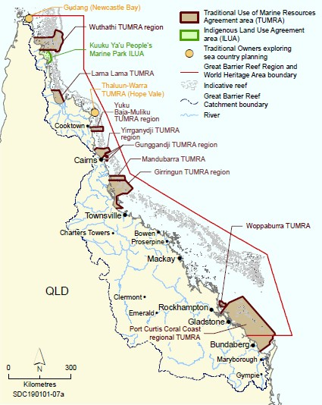GBRMPA also fosters Indigenous community engagement through membership on the Authority Board and the Indigenous Reef Advisory Committee, science and management workshops for Traditional Owners, compliance training, monitoring and traditional ecological knowledge projects.
Figure H.5 Areas of the Great Barrier Reef covered by accredited Traditional Owner agreements, 2018
Source: GBRMPA 2019:148

Reef 2050 Long Term Sustainability Plan – Indigenous Implementation Plan – 2016
In 2016, the Department commissioned the Gidarjil Development Corporation to consult with Traditional Owners and develop a Reef 2050 Indigenous Implementation Plan. The Reef 2050 Indigenous

Implementation Plan (Gidarjil Development Corporation, 2016) was developed to support and guide implementation of the Traditional Owner led actions in the Reef 2050 Plan. Drawing on broad consultation with Traditional Owners, its general findings include:
- Capacity of Traditional Owners is variable across the region;
- Continued support for existing efforts is important;
- Most of the Indigenous actions in the Reef 2050 Plan are closely linked;
- Future consultations need to be undertaken to inform monitoring and reporting; and
- Implementation should focus on coordination, cultural heritage and business capacity. The Report identifies the following three key priority areas for implementation:
- Coordination;
- Cultural Heritage; and
- Business Capacity.
These key areas intersect with the majority of the Traditional Owner actions in the Reef 2050 Plan. For each of these three priorities, the Implementation Plan articulates the known challenges and opportunities, proposes a pathway to address those challenges and identifies the results expected from implementation.
The Report notes that TO Groups within the Great Barrier Reef Marine Park are enthusiastic with a desire to look after and care for their land and sea Country, they are eager to explore opportunities to further develop and expand their capacity. They are also keen on becoming more actively involved than they currently are in collaborative research partnerships to address key Indigenous knowledge gaps. Including for example, a safe and secure location to store information relating to their cultural heritage and traditional knowledge. The TOs stated they are quite keen on having a cloud based database, and with this being a government database, provided the TOs can have control over what information is stored, who has access to this information (levels of encryption) and they are satisfied that appropriate information sharing protocols are in place. The Report notes that Traditional knowledge capture and sharing will facilitate partnerships with Western science, increase traditional knowledge involvement in planning and policies and most importantly protect and retain the knowledge for future generations.
The Report also concluded that varying levels of capacity among TO groups along the Reef are hampering their ability to be more involved than they currently are, and that without better support, their current levels of capacity will not enable them to deliver on all of the TO and other actions in the Reef 2050 Plan.
The Report concludes:
‘An increased focus on collaboration and partnerships will assist to build a level of cultural competency that is required to maintain productive working relationships with Traditional Owner sea country managers. This includes understanding, respecting and valuing Indigenous cultural heritage and knowledge systems. These elements are vital to comprehending the foundations of sea country and the ability to manage it with Traditional Owners effectively.’

Traditional Owners of the Great Barrier Reef: The Next Generation of Reef 2050 Actions – 2017
In 2017 the Australian Government commissioned a consortium of Indigenous and research organisations, led by the Reef and Rainforest Research Centre, to engage with Great Barrier Reef Traditional Owners to better understand and reflect their aspirations for the Great Barrier Reef and deliver on existing commitments. Consortium members included the North Australian Indigenous Land and Sea Management Alliance, Cape York Institute, Commonwealth Scientific and Industrial Research Organisation, the Australian Institute of Marine Science and James Cook University.
The consortium prepared a report, titled ‘Traditional Owners of the Great Barrier Reef: The Next
Generation of Reef 2050 Actions’ (Commonwealth of Australia, 2018b), which provides advice from Great

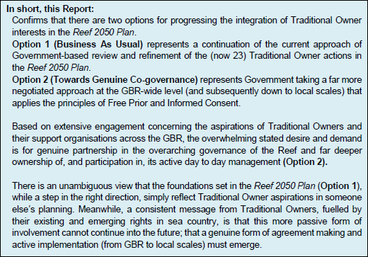
Barrier Reef Traditional Owners about their aspirations for involvement in the management, governance and protection of the Great Barrier Reef. The Report notes that while significant progress has been made with respect to land and sea rights across much of the GBR (catchment and marine) and the emergence of some outstanding examples of Traditional Owners, government agencies and researchers working together in productive partnerships, there is no lasting, continuously improving GBR-wide approach to empowering Traditional Owners in the governance of the GBR. The Report also states that with the future health of the GBR under serious threat from climate change and other stresses, it is now critical to harness the capacity of Traditional Owners and their Sea Country institutions for a new generation of reef protection and management into the future. Figure H.6 is an extract from the Report’s Executive Summary.
Figure H.6 Extract from the Executive Summary of Traditional Owners of the Great Barrier Reef: The Next Generation of Reef 2050 Actions
Source: Commonwealth of Australia, 2018b

The Report makes ten recommendations, including:
- the establishment of a GBR-wide Sea Country Traditional Owner Alliance;
- resourcing the GBR’s leading research institutions to jointly collaborate with Traditional Owners to negotiate a long-term strategy for supporting TO knowledge and research needs (e.g. data sharing agreements, etc.); and
- TOs to be embedded in all aspects of GBR monitoring and evaluation using culturally appropriate approaches (e.g. Strong Country – Strong People Framework).

GBR Outlook Report 2019
The GBR Outlook Report is required to be produced every five years in accordance with the Great Barrier Reef Marine Park Act 1975 (Cth) (section 54). The Outlook Report examines the Great Barrier Reef’s health, pressures, and likely future, and aims to provide a regular and reliable means of assessing reef health and management in an accountable and transparent way. The Outlook Reports are independently

peer reviewed. The GBR Outlook Report 2019 is the third comprehensive report in the series. The Report notes that the region is protected and managed by a partnership between many government agencies, Traditional Owners, stakeholders and community members, and is influenced by activities occurring within and adjacent to the Region, and that actions taken now by managers, Traditional Owners, researchers, stakeholders and the community will matter and make a difference to the Region’s long-term outlook.
The Report also identifies that the Great Barrier Reef Region still faces significant pressures ranging in scale from local to global, and that the greatest threat to the Reef is still climate change:
A comprehensive risk assessment of 45 threats to the Region’s ecosystem and heritage values considered the residual risk, after taking into account the current management regime. The 10 threats identified in 2014 as presenting a very high risk to the Region’s ecosystem and heritage
values are again the highest ranked in 2019. Of the very high-risk threats, most relate to climate change or land-based run-off (water quality) affecting values on a Region-wide scale. Given the current state of the Region’s values, actions to reduce the highest risks have never been more time- critical.

And:

Without additional local, national and global action on the greatest threats, the overall outlook for
the Great Barrier Reef’s ecosystem will remain very poor, with continuing consequences for its heritage values also. The window of opportunity to improve the Reef’s long-term future is now.
Strong and effective management actions are urgent at global, regional and local scales (GBRMPA, 2019:vi).

In relation to research activities, the Report states:
Inclusion of Traditional Owners in research within their sea country is limited and research results are often not disseminated to Traditional Owners. However, examples of collaboration are increasing. These include: a protocol between the Wuthathi Aboriginal Corporation and Queensland Parks and Wildlife Service to manage permits for research in the Shelburne Bay area in Cape York; new guidelines for Woppaburra Traditional Owner Heritage Assessments in the Keppel islands region; and involvement of Traditional Owners in the development and implementation of research, monitoring and beach restoration at Raine Island (GBRMPA 2019:205).
Multiple managing agencies continue to have representation on major committees relating to research on the Reef. Many of these are coordinated through the overarching Reef 2050 Plan. However, a number of researchers noted decreased engagement from the Marine Park Authority’s staff on research priorities, which they attributed to a loss of key staff members at the authority over the past few years. The reduced engagement may also be a consequence of diversified sources of funding for research in the Region, with significant research funds being managed through the Commonwealth Department of the Environment and Energy (GBRMPA, 2019:206).

Research Snapshot
GBRMPA has played an active role in the following NESP research projects through the TWQ Hub:
- Building Indigenous livelihood and co-management opportunities in the Northern GBR –
ecosystem services and conservation governance for water quality. (TWQ Hub Project No. 2.3.3)
- Working with traditional owners and local citizens to better manage GBR estuarine wetlands. (TWQ Hub Project No. 2.3.4)
- Working with the community to understand the use of space by dugongs and green turtles in Torres Strait. (TWQ Hub Project No. 3.2 Part 1)
- Improving the estimates of abundance of dugongs and large immature and adult-sized green turtles in Western and Central Torres Strait. (TWQ Hub Project No. 3.2 Part 2)

- The IMS 2050 Human Dimensions Project: cost-effective indicators and metrics for key GBRWHA human dimensions. (TWQ Hub Project No. 3.2.2)
- Traditional Owners and Sea Country in the Southern Great Barrier Reef - Which Way Forward? (TWQ Hub Project No. 3.9)
- Indigenous Coral Reef Tourism. (TWQ Hub Project No. 4.7)
- Assessing the Gulf of Carpentaria mangrove dieback. (TWQ Hub Project No. 4.13)

Murray Darling Basin Authority (MDBA)
The Murray Darling Basin Authority (MDBA) is established under the Water Act 2007 (Cth) as an independent expertise-based statutory agency.
The MDBA’s purpose is to:
- Prepare, implement and review an integrated plan for the sustainable use of the Basin's water resources;
- Operate the River Murray system and efficiently deliver water to users on behalf of partner governments;
- Measure, monitor and record the quality and quantity of the Basin's water resources
- Supporting, encourage and conduct research and investigations about the Basin's water resources and dependent ecosystems;
- Advise the Australian Government Minister for Water Resources on the accreditation of state water resource plans;
- Provide water rights information to facilitate water trading across the Basin; and
- Engage and educate the Australian community about the Basin's water resources.
The MDBA recognises that the health of the Basin benefits from meaningful, equitable, inclusive and respectful partnership with Traditional Owners and their involvement in water planning and management.

Indigenous Engagement
The MDBA has developed partnership agreements with the Northern Basin Aboriginal Nations (NBAN) and the Murray Lower Darling Rivers Indigenous Nations (MLDRIN). NBAN and MLDRIN are independent, self- determining, TO-based organisations with a primary focus on natural resource management, making them invaluable partners in managing water in the Basin. The MDBA works with NBAN and MLDRIN and a wide range of other community organisations to help raise public awareness about Aboriginal interests and concerns relating to water and invests considerable effort into collecting and sharing Aboriginal information across the Basin.
According to the MDBA (MDBA, 2019), changes proposed for the 2022 Basin-wide environmental watering strategy require more research and other work, most of which is underway, but for the purposes of the 2019 Update, the MDBA is proposing to include First Nations’ objectives and outcomes for shared benefits of environmental water, among other proposed actions.
The MDBA is committed to working with NBAN and MLDRIN to develop and incorporate Basin Nation’s environmental watering objectives into environmental water planning and management. The First Nations Environmental Water Guidance (FNEWG) Project aims to develop a defined and transparent methodology for First Nations’ environmental watering objectives to be incorporated in environmental water planning.
Northern Basin:
- First Nations Environmental Watering Guidance (FNEWG) aims to gather the environmental watering objectives of 21 Nations across five environmental watering themes.
- NBAN is working with the MDBA and the CEWO to integrate these objectives into the 2020-21 Basin annual environmental watering priorities and long-term environmental water planning.

Southern Basin:
- First Nations Environmental Water Objectives (FNEWO) working in partnership with the MBDA and the CEWO, MLDRIN aim to develop an effective and equitable mechanism for First Nations environmental watering objectives to be included in the environmental watering frameworks for the Murray-Darling Basin.
- MLDRIN has prepared a collaborative design report outlining sources of information available to nations to develop watering objectives, the resources required by Nations to undertake this work and relevant decision-making structures.
The MDBA has also actively engaged with Indigenous peoples across the Basin on several other research projects, including:
- Water resource planning to ensure that the concerns of TOs (i.e. their stated objectives and outcomes based on their values and uses) are taken into account in the water resource planning process and a level of protection of Aboriginal values and uses are maintained in the WRPs.
- Reporting on Aboriginal participation in water for the environment. In June 2018 the Commonwealth Minister responsible for water issued the Water (Indigenous Values and Uses) Direction 2018, under Section 175 of the Water Act 2007 (Cth). Following from that directive, at the end of each watering year, the MDBA reports on how, when planning for environmental watering, the holders of held water for the environment have considered Indigenous values and uses and involved Aboriginal people.
- The Living Murray (TLM) Indigenous Partnerships Program provides the opportunity for Aboriginal people to have a meaningful role in the management of icon sites in the Basin.
- The Aboriginal Weather Watchers Project was undertaken by the MDBA between 2016 and 2019 to record the impacts of weather on the everyday lives of Aboriginal people in the Murray–Darling Basin and explore the impact of weather on Aboriginal uses and values of water-dependent natural resources.
- Aboriginal Water Entitlements Program. In May 2018, the Australian Government announced funding of $40m for the purchase of water entitlements by First Nations peoples, to be shared equally between the northern and southern Basin.
- Ranger groups and interest in expansion to water. There is scope to expand and enhance on- ground programs, such as ranger programs or Aboriginal water facilitators, to support the participation and involvement of First Nations communities in water resource management. Four new ranger positions are to be created in the Menindee Lakes and surrounding region to support First Nation people to manage land and water in the region to preserve and manage important environmental assets.

Research Snapshot
It is noted however, that no environmental or climate science research has been undertaken by the NESP Hubs in the Murray Darling Basin with the MDBA, MLDRIN or NBAN.
National Cultural Flows Research Project
The key area of research to Indigenous peoples has been the National Cultural Flows Research Project. This project was driven by and for Aboriginal people, and has, over seven years, sought to establish a national framework for cultural flows. Cultural flows are water entitlements that are legally owned and managed by First Nations to improve the spiritual, cultural, environmental, social and economic conditions of these Nations.
The National Cultural Flows Research Project¹⁵ developed rigorous and defendable knowledge on First Nations' water interests for the benefit of Aboriginal people. The project drew on a range of scientific

15 https://www.mdba.gov.au/discover-basin/water/cultural-flows and http://www.culturalflows.com.au/

research methodologies and generations of cultural knowledge to provide a greater understanding of Aboriginal values relating to natural resources, especially water; equip First Nations with information and tools to ensure that Aboriginal water requirements and preferences are reflected in water policy; and inform the development of new governance approaches to water management that incorporate aspects of First Nations' governance and capacity building.
While the focus of the National Cultural Flows Research Project was on the Murray Darling Basin, the project was established for the benefit of all First Nations across Australia. Through the use of case study sites that consider cultural flows in different cultural, social, economic and ecological settings, the project has developed a framework, principles and solid evidence base that can be applied outside of the Basin, to inform the recognition of Aboriginal water rights in different jurisdictions.
Basin Science Platform
In 2017, the Ministerial Council requested the Basin Officials Committee (BOC) to develop a science strategy consistent with the Basin Plan that enables both a clear science platform, and an adaptive management approach to implementing and operating the package in time for signing of the IGA. The Basin Science Platform is about identifying the science/knowledge needs to inform decision making processes to successfully implement the Basin Plan. In February 2019, MDBA commissioned a gap analysis and strategic plan for a Basin Scientific Platform. The project contains two broad components. The first involves identifying policy drivers, implementation activities underway between now and 2026, the relevant science currently underway, areas for improvement in the current scientific approach and residual knowledge gaps to be addressed. The second element involves development of a model and high- level plan for the implementation and ongoing management of the Basin Science Platform, to ensure ongoing sustainability.
Climate Change, Science and Evaluation
In February 2019, the MDBA announced that it is launching a new phase of work into the impact of climate change on the environment, industries and communities of Murray–Darling Basin. A discussion paper has been released which signalled the MDBA’s commitment to a major research program on climate change in the Basin, which will be informed by a series of workshops convened by MDBA’s Advisory Committee on Social, Economic and Environmental Sciences. It is expected this research will be critical to ongoing adaptive management decisions, along with the formal built-in reviews of the Basin Plan. The MDBA is focusing on four key actions that respond to the risks and prepare for the impacts of climate change, including refining existing arrangements; buffering the system from stress; enhancing with new arrangements; and adapting to future changes.

Torres Strait Regional Authority (TSRA)
The Torres Strait Regional Authority (TSRA) is an Australian Government Statutory Authority established on 1 July 1994 under the Aboriginal and Torres Strait Islander Commission Act 1989 (Cth), which is today known as the Aboriginal and Torres Strait Islander (ATSI) Act 2005 (Cth).
The TSRA provides regional coordination of policies and programs of benefit to Torres Strait Islander and Aboriginal people living in the region. This is the only such regional Indigenous body in Australia. The TSRA consists of an elected arm and an administrative arm. The elected arm is comprised of 20 elected representatives who are Torres Strait Islander and Aboriginal people living in the Torres Strait region. The TSRA is administered by a Chief Executive Officer and staff who implement and manage TSRA programs. The Torres Strait Regional Authority delivers services to all communities in the Torres Strait and to Bamaga and Seisia on Cape York.
The TSRA has the responsibility to:

- Formulate, coordinate and implement programs for Torres Strait Islander and Aboriginal people living within the region;
- Monitor the effectiveness of these programs, including programs conducted by other bodies;
- Advise the Minister for Indigenous Affairs on matters relating to Torres Strait Islander and Aboriginal Affairs in the Torres Strait;
- Recognise and maintain the special and unique Ailan Kastom of the Torres Strait Islander people living in the Torres Strait Region; and
- Undertake activities necessary to perform its function as defined by the ATSI Act 2005.
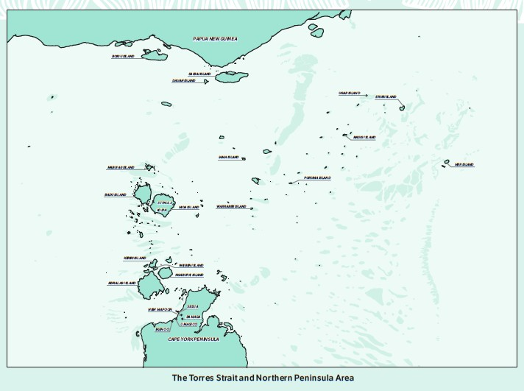The Torres Strait region stretches 150 km from Cape York Peninsula to 3.73 km off the south-west coast of Papua New Guinea (see Figure H.7). Its western-most border is 73.5 km from Indonesia. The region covers an area of approximately 48,000 km2. The region straddles the Australia – Papua New Guinea international border and contains the Torres Strait Protected Zone, established under the Torres Strait Treaty between the two countries to acknowledge and protect the traditional way of life and livelihood of their Indigenous inhabitants.
Figure H.7 The Torres Strait and Northern Peninsula Area
Source: TSRA

Indigenous Engagement
The region is identified by the Australian Bureau of Statistics as the Torres Strait Indigenous Region. The majority of the region’s population is Indigenous, comprising two distinct Indigenous races – Torres Strait Islander and Aboriginal peoples. The population is located on eighteen island communities in the Torres Strait and five Torres Strait Islander and Aboriginal communities on the Northern Peninsula Area of Cape York (Seisa, Bamaga, Umagico, Injinoo, New Mapoon).

TSRA has therefore adopted the TSRA Cultural Policy and the TSRA Cultural Protocols Guide to assist staff to provide a consistent culturally respectful and professional level of service to all communities in the Torres Strait region. The Policy and Protocols Guide are also available to the public and other government agencies and non-government organisations as they contain comprehensive information on communication, community visits and engagement, and working, researching and staying in communities.
All requests to undertake research in the Torres Strait must be made to the local Torres Strait island Regional Council or the Northern Peninsula Area Regional Council for consideration and community endorsement. If they agree, then there are certain conditions that have to be met before the research can proceed.

Research Snapshot
The TSRA has been actively involved in several environmental and climate science research projects in the region, including the following.
Traditional Ecological Knowledge.
The Traditional Ecological Knowledge (TEK) Project is a database system managed by the Torres Strait Regional Authority (TSRA) Land and Sea Management Unit (LSMU). The TEK project was initiated by TSRA in 2011 and is now established in 11 communities (over 10 islands) in the Torres Strait through funding from the National Landcare Program (NLP) program. The Traditional Ecological Knowledge (TEK) Project supports participating Torres Strait communities to utilise a TEK database for the collection, protection and controlled sharing of cultural and natural resource information whilst ensuring adherence to cultural protocols.
In June 2016, the TSRA Land and Sea Management Unit completed a review of the TEK project to determine what communities thought of the system, how system use can be improved, what traditional knowledge communities would like protected and how the TSRA can work with communities to increase profile of TEK in communities.
The key recommendations arising from the TEK Project Review include:
- Establish a TEK Working Group to prioritise recommendations arising from TEK Review;
- Improve community access to TEK systems through investigation of offline data upload;
- Further promotion of TEK Systems;
- Focus on key TEK communities in order to acquire a baseline level of ecological data in these;
- Increase staffing levels for TEK Project to adequately support TEK Systems;
- Work with communities to develop discrete TEK projects;
- Continue to train rangers and LSMU staff on the importance of TEK, incorporation of TEK into LSMU activities and recording methods for TEK;
- Investigate incorporation of TEK data sets into land and sea management planning; and
- Review the consultancy arrangement for the TEK Project and redefine deliverables. The Community priorities for preserving TEK are shown in Figure H.8.

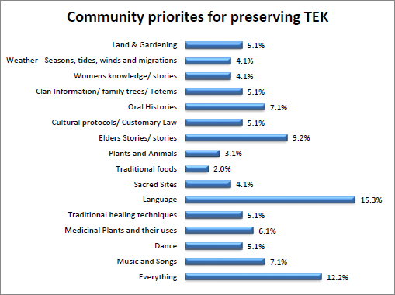

Figure H.8 Community priorities for preserving TEK
Source: Traditional Ecological Knowledge (TEK) Review, Community Summary, August 2016.
Torres Strait Climate Strategy 2014-18. Building Community Adaptive Capacity and Resilience
The revised Torres Strait Climate Change Strategy 2014-2018 (the Strategy) (TSRA, 2014) highlights current climate trends and recent updates to climate change predictions for the region. The Strategy identifies a number of priority responses through an Action Plan. The Action Plan incorporates and builds on existing efforts from the 2010–2013 Strategy, focused on how the region can best adapt to inevitable changes as well as how it shows moral leadership to reduce greenhouse gas emissions. Actions have been grouped into five key themes of culture and traditional knowledge; environment and ecosystems; settlements and infrastructure; people and communities; and communication and capacity building. It also highlights specific monitoring needed to track changes in these areas.
The Action Plan also identifies the need for further research that targets species vulnerable to climate change (e.g. corals, fishes, crayfish, marine turtles, dugongs, seagrasses, pelagic foragers) to optimise the effectiveness of resilience-based management.
An earlier report identified a number of knowledge gaps, including lack of high-quality data; El Niño- Southern Oscillation (ENSO) and the Indian Ocean Dipole; tropical cyclones in the region; Climate Change Projections from Global Climate Models; and high-resolution regional climate models. (Suppiah et al, 2010:54),
Fisheries Research in the Torres Strait
A Procedural Framework for Researchers in the Torres Strait 2018 was commissioned by the Protected Zone Joint Authority’s Torres Strait Scientific Advisory Committee (TSSAC) and funded by the Torres Strait Regional Authority (TSRA). The aim of this project is to review the Guide for Researchers Working in the

Torres Strait 2012 (the Guide) and develop a procedural framework to support fisheries research and management to ensure research conducted in the Torres Strait involves appropriate consultation and engagement with key stakeholders¹⁶ prior to, and throughout, the undertaking of each research project; and consultation and engagement outcomes are clearly documented in a form that is supported by community stakeholders. The project emerged from the TSSAC identifying a priority need for improvements in the way research is undertaken in the Torres Strait region.

TSRA involvement with NESP research projects
TSRA is currently participating in two NESP research projects being undertaken by the TWQ Hub.
Identifying the water quality and ecosystem health threats to the Torres Strait from the Fly River runoff (TWQ Project No. 5.14)
Runoff from the Fly River in Papua New Guinea (PNG) influences water quality conditions in the Torres Strait region. Recent work (NESP Project 2.2.1 and 2.2.2) has clearly demonstrated that this influence is largely constrained to the northern Torres Strait, as far east as Bramble Cay and at least as far west as Boigu Island. The southern extent of influence is considered to be limited to within 40-50km of the PNG coast in the western areas, and around 80km in the eastern areas. The intensity of this influence, and the potential ecological impacts, are still not well understood. Trace metal concentrations are higher in the northern Torres Strait around Boigu and Saibai, however it is not clear whether this enrichment is natural or the result of mine derived inputs of trace metals.
Further investigation is required to understand the prevalence and frequency of the extension of the Fly River plume into the northern Torres Strait, and further characterisation of plume constituents, particularly sediment and trace metals in comparison to previous results including the Torres Strait Baseline Study.¹⁷
Improving historical estimates of abundance and distribution of dugongs and large green turtles in western and central Torres Strait (TWQ Project No. 3.2)
This project is aimed at improving the accuracy of aerial survey estimates of the size and distribution of dugong and green turtle populations in western and central Torres Strait by: (1) collecting and analysing data on their movements and diving behaviour, and (2) estimating the proportion of turtles seen during aerial surveys that are the large female green turtles harvested by Indigenous hunters. These data will then be used to (re)estimate the size and distribution of the populations of dugongs and harvestable green turtles in Torres Strait by (re) analysing historical aerial survey data collected in 2001, 2005, 2006, 2011 and 2013.¹⁸

Department of the Prime Minister and Cabinet (PM&C) and the National Indigenous Australians Agency (NIAA)
The Department of the Prime Minister and Cabinet (PM&C) provides high quality advice and support to the Prime Minister, the Cabinet, Portfolio Ministers and Assistant Ministers to achieve a coordinated and innovative approach to the development and implementation of Government policies. PM&C coordinates and develops policy across the Government in economic, domestic and international issues, Aboriginal and Torres Strait Islander affairs and public service stewardship.

16 Including native title representatives, Registered Native Title Body Corporates or RNTBCs, relevant fisheries associations and fisheries industry stakeholders.
17 https://nesptropical.edu.au/index.php/round-5-projects/project-5-14/
18 https://nesptropical.edu.au/index.php/round-1-projects/project-3-2/

The PM&C portfolio comprises a number of Commonwealth entities and companies under the Public Governance, Performance and Accountability Act 2013 (PGPA Act), which includes the following Indigenous-related entities:
- National Indigenous Australians Agency (NIAA)
- Anindilyakwa Land Council
- Australian Institute of Aboriginal and Torres Strait Islander Studies
- Central Land Council
- Indigenous Business Australia
- Indigenous Land and Sea Corporation
- Northern Land Council
- Tiwi Land Council
- Torres Strait Regional Authority
- Wreck Bay Aboriginal Community Council.
The following Commonwealth companies also fall within the PM&C portfolio of responsibilities:
- Aboriginal Hostels Ltd
- Outback Stores Pty Ltd.
The Department has three key purposes:
- Supporting the Prime Minister, as the head of the Australian Government, the Cabinet and portfolio ministers.
- Providing advice on major domestic policy, national security and international matters.
- Improving the lives of Indigenous Australians.
On 12 June 2019 the Prime Minister announced the transition of the Indigenous Affairs Group within PM&C to become the National Indigenous Australians Agency (NIAA). The new NIAA began operations on 1 July 2019. The NIAAs functions include:
- to lead and coordinate Commonwealth policy development, program design and implementation and service delivery for Aboriginal and Torres Strait Islander peoples;
- to provide advice to the Prime Minister and the Minister for Indigenous Australians on whole-of- government priorities for Aboriginal and Torres Strait Islander peoples;
- to lead and coordinate the development and implementation of Australia’s Closing the Gap
targets in partnership with Indigenous Australians; and
- to lead Commonwealth activities to promote reconciliation.
The NIAA has several focus areas within its purview, with the Environment as the focus area of most relevance to this review of Indigenous environmental and climate science research priorities and engagement under the NESP.
The two key programs of relevance to this report are the IPA Program and the Indigenous Rangers Program.

Indigenous Protected Areas (IPA) Program
This program has been helping Indigenous communities voluntarily dedicate their land or sea Country as IPAs since 1997.
Briefly, the following statistics summarise the success of the IPA Program to date:
- The first dedicated IPA, the Nantawarrina IPA, celebrated its 20th anniversary on 27 August 2018.
- There are 76 IPAs that make up almost 44 per cent of Australia’s National Reserve System,
managed for the benefit of all Australians.

- Over 60 per cent of IPAs are managed by Australian Government funded Indigenous ranger groups. (See Figure H.9)
- 839 Aboriginal and Torres Strait Islander people are employed in full-time, part-time and casual jobs under the IPA Program.
Since the Machinery of Government changes in 2013 that created the Indigenous Advancement Strategy which placed it in the portfolio of the Department of the Prime Minister and Cabinet, responsibility for the IPA Program has been split between two Departments. Under current Administrative Arrangements, the NIAA is responsible for the ongoing funding to IPAs through the Indigenous Ranger Program (discussed below) and the Department of Agriculture, Water and the Environment retains responsibility for the selection of new IPAs.

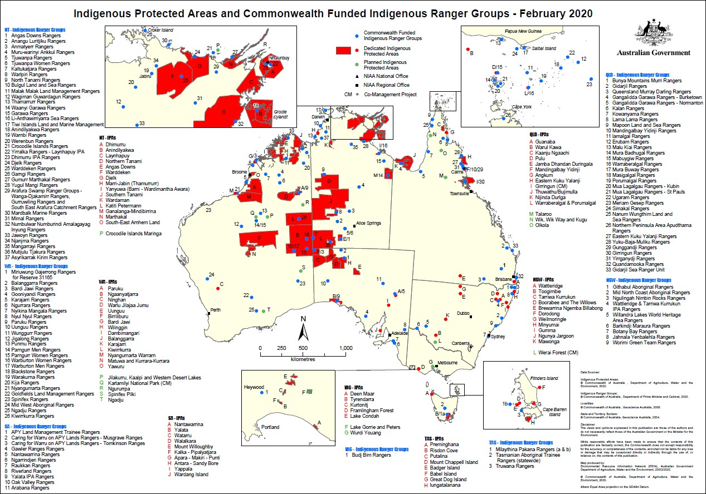

Figure H.9 Indigenous Protected Areas and Commonwealth Funded Ranger Groups Map – February 2020
Source: NIAA

Indigenous Rangers (formerly Working on Country)
Indigenous ranger projects were first funded in 2007 through the former Working on Country (WoC) Program to create meaningful employment, training and career pathways for Aboriginal and Torres Strait Islander people working in land and sea management. Table H. 1 shows the number Indigenous ranger groups and full-time equivalent Indigenous ranger positions under the Indigenous Ranger program.
However, the program has created more than 2,100 full-time, part-time and casual jobs for First Australians around the Country.
Table H. 1 Funded Ranger projects and full time equivalent contracted positions as at 2018

Funded ranger projects | 30 September 2018
Indigenous ranger groups | 123
Indigenous rangers (full time equivalent contracted positions) | 839
Source: PM&C website.19
Indigenous ranger projects support Indigenous people to combine traditional knowledge with conservation training to protect and manage their land, sea and culture. Indigenous ranger groups also develop partnerships with research, education, philanthropic and commercial organisations to share skills and knowledge, engage with schools, and generate additional income and jobs in the environmental, biosecurity, heritage and other sectors.
By achieving employment and environmental outcomes, alongside wider social, cultural and economic benefits, the work of Indigenous rangers is valued by Indigenous communities across Australia. Independent evaluations of the Indigenous Rangers and IPA programs in both 2006 (Gilligan, 2006) and in 2016 (SVA Consulting, 2016) found that rangers had experienced increased confidence and skills through their training and work on Country. Rangers reported they felt more pride, self-worth, health and wellbeing, with closer connections to family, culture and Country. Ranger groups also reported a wide range of community benefits as a result of the programs, including safer communities, strengthened language and culture, an ability to find meaningful employment, increased respect for women, and more role models for younger people.

Research Snapshot - Social Return on Investment in IPAs
In 2016, PM&C commissioned SVA Consulting to understand, measure or estimate and value the changes resulting from the investment in five IPAs across Australia. The Social Return on Investment (SROI) methodology was used to complete each of these analyses, which were informed by interviews with 143 stakeholders, as well as desktop research canvassing relevant qualitative and quantitative data.
The study found that the IPA and Working on Country (WoC) programs are:
- Engaging Indigenous Australians in meaningful employment to achieve large scale conservation outcomes.
- Facilitating reconnection with Country, culture and language to achieve exceptional levels of engagement among Indigenous Australians which is driving positive social, economic, cultural and environmental outcomes.
- Helping to catalyse the development of an Indigenous land and sea-based economy, empowering Indigenous landowners to manage their Country in accordance with their priorities.
- This report synthesises findings from across the analyses, exploring the relevant drivers of value and alignment of program outcomes with PM&C's Strategic Priorities.
The Consolidated Report concluded that over the period between the 2009 and 2015 financial years, an investment of $35.2m from Government and a range of third-party investors has generated social, economic, cultural and environmental outcomes with an adjusted value of $96.5m (SVA Consulting 2016).

19 https://www.niaa.gov.au/indigenous-affairs/environment/indigenous-rangers-working-country

Department of Agriculture, Water and the Environment (DAWE)
The Department of Agriculture, Water and the Environment (DAWE) was established on 1 February 2020. The Department is responsible for the administration of over 125 statutes and regulations relating to agriculture, water and the environment. Its functions also include responsibility for environmental information and research, environment protection and biodiversity conservation, natural built and cultural heritage, and coordination of climate change science research activities, among many other matters relating to other parts of the portfolio.
This overview focusses on the following aspects because of their relevance to Indigenous environmental and climate science research themes and questions:
- The Environment Protection and Biodiversity Act 1999 (Cth) (EPBC Act);
- The Minister’s Indigenous Advisory Committee (IAC) established under the EPBC Act;
- The State of the Environment (SoE) Report;
- Australia’s Marine Bioregions, the National Representative System of Marine Protected Areas (NRSMPA) and Australia’s Marine Parks;
- Australia’s Terrestrial Bioregions, The National Reserve System and IPAs;
- Indigenous heritage
- Commonwealth National Parks;
- National Landcare program;
- Commonwealth Environmental Water Office (CEWO);
- Australian Bureau of Agricultural and Resource Economics and Sciences (ABARES) and their inventory of Indigenous owned, managed or co-managed land.
The following is a very brief overview of the functions and relevance to Indigenous environmental and climate science research themes and questions.

The Environment Protection and Biodiversity Act 1999 (Cth) (EPBC Act)
The EPBC Act is Australia’s central piece of environmental legislation which provides a framework to protect and manage nationally and internationally important flora, fauna, ecological communities and heritage places - defined under the EPBC Act as Matters of National Environmental Significance (MNES). The nine matters of MNES are:
- world heritage properties;
- national heritage places;
- wetlands of international importance (often called 'Ramsar' wetlands after the international treaty under which such wetlands are listed);
- nationally threatened species and ecological communities;
- migratory species;
- Commonwealth marine areas;
- the Great Barrier Reef Marine Park;
- nuclear actions (including uranium mining); and
- a water resource, in relation to coal seam gas development and large coal mining development.
The EPBC Act provides for the recovery plans for threatened species, setting out what must be done to protect and restore important populations of threatened species and habitat, as well as how to manage and reduce threatening processes. Recovery plans achieve this aim by providing a planned and logical framework for key interest groups and responsible government agencies to coordinate their work to improve the plight of threatened species and/or ecological communities.
Case Study G.1 is an example of the kind of partnerships with Indigenous peoples and other partners that can be developed around threatened species and their recovery.

CASE STUDY G.1: Psephotus chrysopterygius — Golden-shouldered Parrot, Alwal

National recovery plan for the Golden-shouldered Parrot (Psephotus chrysopterygius) 2003-2007
The golden-shouldered parrot is one of 20 birds that the Australian Government has prioritised resource allocation to support the species recovery effort. This species is a priority for investment primarily because of the support afforded to actions to recover it through community partnerships. Priority actions needed to recover this species include protecting termite mounds and associated foraging habitat, controlling feral pigs and feral cats and implementing suitable burning regimes.
The golden-shouldered parrot, or alwal, is a significant cultural species for the Olkola people of Cape York. This brilliantly coloured little parrot lives in tropical savanna woodland, spending much of its time on the ground feeding on grass seeds. Alwal have the unusual habit of nesting in old termite mounds which makes them vulnerable to feral pigs and cats.
The Olkola Aboriginal Corporation, Bush Heritage and landholders are working together with Queensland Parks and Wildlife Service to implement actions from the recovery plan.
The preface of the new draft Recovery Plan states:
‘Traditional Owner groups participating in the golden-shouldered parrot Recovery Team welcome the opportunity to work with partners who can help to meet the objectives of the Recovery Plan. All requests to work in partnership with the Recovery Team and participating Traditional Owner groups should be directed to the Recovery Team secretariat at recoveryteam@olkola.com.au. Potential partners will be requested to complete an Expression of Interest form to identify the purpose of their proposed work and whether there is a good alignment of purpose with the Recovery Plan objectives. This process is necessary to protect Indigenous interests in golden-shouldered parrot recovery as outlined in Specific Objective 1.1 of the recovery program.’
Sources:
https://www.environment.gov.au/biodiversity/threatened/recovery-plans/recovery-plan-golden- shouldered-parrot-psephotus-chrysopterygius-2003-2007
https://www.environment.gov.au/system/files/resources/f2ba8fe9-2091-4e37-84ac- dc1ee04c5179/files/p-chrysopterygius.pdf
http://www.environment.gov.au/cgi-bin/sprat/public/publicspecies.pl?taxon_id=720 https://www.bushheritage.org.au/newsletters/2016/summer/bring-alwal-home

An independent review of the EPBC Act led by Professor Graeme Samuel AC is currently underway and is due to report later this year. The Review has released a Discussion Paper (Samuel, 2019) which notes that respect for and appreciation of Aboriginal and Torres Strait Islander people and their cultures has deepened since the introduction of the EPBC Act, and their role could be strengthened by placing an emphasis on early and genuine engagement with them, and updating the objects of the Act to provide more emphasis and clarity on the involvement and interests of Indigenous Australians.

Indigenous Advisory Committee (IAC) established under the EPBC Act
The Indigenous Advisory Committee (the Committee) is a statutory committee established under the Environment Protection and Biodiversity Conservation Act 1999 (EPBC Act) [section 505A]. the Committee’s function is to advise the Minister on the operation of the EPBC Act and on other relevant matters as requested by the Minister, taking into account the significance of Indigenous peoples' knowledge of the management of land and the conservation and sustainable use of biodiversity.
All Committee members are Indigenous Australians and are ministerially appointed based on expertise in Indigenous land and sea management, conservation and sustainable use of biodiversity, and cultural heritage management. The IAC meets about once or twice per year and Bulletins from each meeting are placed on the web.

An examination of the Bulletins shows that over the last five years the IAC has provided regular input into the NESP, providing valuable insights and feedback on current program delivery, ensuring greater transparency in how local research priorities are considered, the need to identify best practice approaches and seek more consistency in Indigenous engagement across the Hubs.

The State of the Environment (SoE) Report
Every 5 years, the Australian Government commissions an independent review of the state of the environment (SoE). The purpose of national SoE Reports is to provide all Australians with authoritative information on the state of the environment that sustains our economy and wellbeing, and the Australian public, the Australian Government and other decision-makers responsible for managing our environment with an assessment of how effectively the Australian environment is being managed and what the key national environmental issues are.
The most recent SoE report was completed in 2016. The structure of the SoE report does not necessarily single out Indigenous issues as a theme, but that is not to say that the SOER does not include a discussion of such matters or related matters. Indeed, it does, across a number of themes, including heritage, land and water, pressures affecting the environment, the marine environment and other matters.
Among the many matters discussed in the SoE is mention of the use of land and vegetation for carbon sequestration by Indigenous land owners (Figure H.10 left) and the development and take up of innovative scientific tools by Indigenous Rangers for harvesting biodiversity observations and monitoring long term change in our environment (Figure H.10, right) (Jackson et al, 2017:32, 34,76-77).
For the 2021 Report, the State of the Environment (SoE) Taskforce is designing a culturally appropriate process to ensure authoritative Indigenous voices and cultural perspectives about environmental condition and change underpin the 2021 National Report.
Drawing on the advice of the IAC, the 2021 report will bring together a mix of traditional, scientific and regional knowledge to inform decision making for better environmental outcomes, including Indigenous knowledge about caring for Country. The use of storytelling using culturally appropriate communication mediums like videos, will ensure the report can be communicated back to Indigenous audiences.

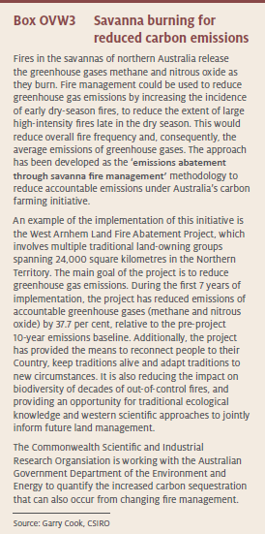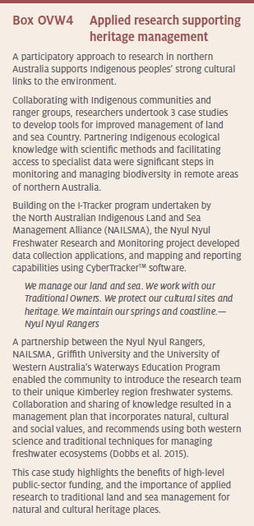

Figure H.10 Savanna Burning for reduced carbon emissions (left). Applied research supporting Indigenous heritage management (right)
Source: Jackson et al 2017:34, 77)

Australia’s Marine Bioregions, National Representative System of Marine Protected Areas (NRSMPA) and Australia’s Marine Parks
Australia’s marine jurisdiction is about double the size of Australia’s land mass and 4 per cent of the world’s oceans. The Integrated Marine and Coastal Regionalisation of Australia (IMCRA v4.0) (Figure H.11) is a spatial framework for classifying Australia's marine environment into bioregions that make sense ecologically and are at a scale useful for regional planning. These bioregions are the basis for the development of a National Representative System of Marine Protected Areas (NRSMPA).

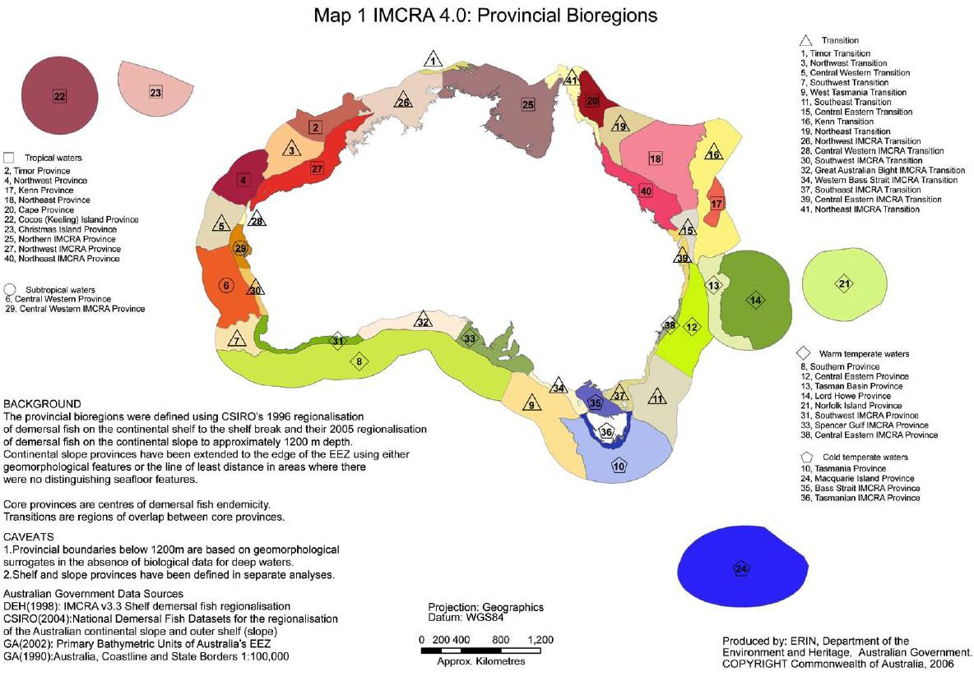
Figure H.11 Integrated Marine and Coastal Regionalisation of Australia (IMCRA v4.0)
Source: DAWE

Australia’s National Representative System of Marine Protected Areas (NRSMPA) aims to establish and manage a comprehensive, adequate and representative system of marine protected areas to contribute to the long-term ecological viability of marine and estuarine systems, to maintain ecological processes and systems, and to protect Australia’s biological diversity at all levels.
Guidelines for establishing the NRSMPA were developed by an inter-governmental Task Force on Marine Protected Areas and agreed to by all Australian governments in 1998. The Australian Government later developed a set of Goals and Principles to apply the guidelines in Commonwealth Waters. These Goals and Principles provide a consistent framework for identifying new marine reserves in Commonwealth Waters and emphasise the strong role of science in the process. Consistent with the Goals and Principles, the Australian Government's objective in developing the regional networks of marine reserves has been to achieve a significant conservation outcome while seeking to minimise adverse impacts on users of the marine environment. The general approach was to design new marine reserves that, where possible, avoided areas highly valued by industry groups and recreational users.
Australian Marine Parks (Commonwealth reserves are proclaimed under the EPBC Act and are located in Commonwealth waters that start at the outer edge of state and territory waters, generally three nautical miles (approximately 5.5 km) from the shore, and extend to the outer boundary of Australia’s exclusive economic zone, 200 nautical miles (approximately 370 km) from the shore.
Marine parks have also been established by state and territory governments in their respective waters under the NRSMPA.
Combined, these cover about 3.3 million square kilometres or 36 per cent of our oceans, as shown in Figure H.12, effectively fulfilling the Australian Government’s commitment to establishing the NRSMPA.

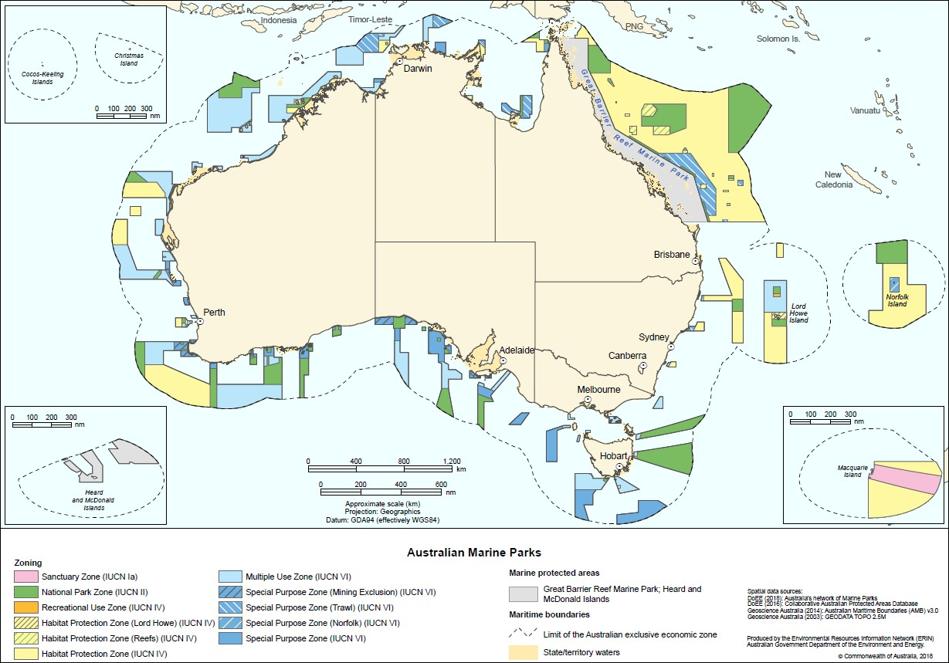
Figure H.12 Australian Marine Parks
Source: DAWE

The Commonwealth manages the 58 Australian Marine Parks located within Commonwealth waters – those over 5.5 kilometres from the coast. The Great Barrier Reef marine park is managed by the Great Barrier Reef Marine Park Authority and the Heard Island and McDonald Islands marine park is managed by the Australian Antarctic Division.
The Director of National Parks has management plans in place that set out how Australia’s Marine Parks are managed. There are six management plans, one for each of the five marine park networks (the North, North-west, South-west, South-east and Temperate East networks) and one for the Coral Sea,
The Director of National Parks acknowledges the national and international rights and cultural interests of Indigenous people and that the effective management of Australian Marine Parks depends in part on developing partnerships with various stakeholders, including TOs.
The Director of National Parks has established partnerships with Aboriginal Corporations representing traditional owners to support collaborations. These partnerships are supported through Collaborative Deeds, which provide for the shared development and implementation of Project Schedules. Each Collaborative Deed covers the cultural values of the respective park. As understanding of cultural values in Australian Marine Parks improves it is anticipated that further opportunities for collaboration with traditional owners will be identified and supported through these types of partnerships.
The Collaborative Deeds also recognise Indigenous Cultural Intellectual Property (ICIP). The management of ICIP under these agreements is flexible to enable traditional owners and relevant Aboriginal Corporations to guide how ICIP is captured in Project Material. This aims to recognise and provide for traditional owners’ rights to free, prior and informed consent in relation to recording, storing and sharing cultural material.
The Director of National Parks has also developed a set of collaborative management principles in conjunction with Indigenous representatives to support Aboriginal and Torres Strait Islander people to engage in the management of Australian Marine Parks (Figure H.13). These principles inform the approach

to implementing the Management Plans, as well as the development and implementation of actions in each marine park.
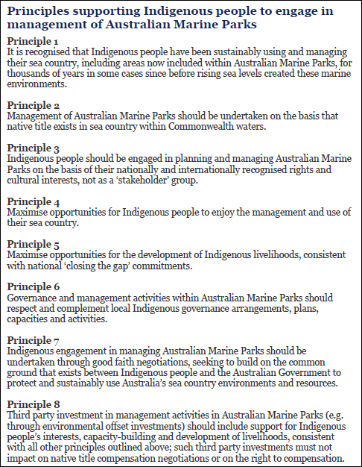

Figure H.13 Principles supporting Indigenous engagement in Australia’s marine parks
Source: DAWE

An Indigenous engagement program enables the Director of National Parks to work with Indigenous organisations, land councils and Indigenous ranger groups to establish collaborative projects for marine parks and to protect cultural values. The program seeks to recognise and respect the ongoing cultural responsibilities of Indigenous people to care for sea Country and support multiple benefits for traditional owners. The program outcomes include social, cultural and economic benefits for traditional owners, and partnerships with traditional owners and Indigenous groups to manage sea Country in marine parks.
National level actions under this program include developing an Australian Marine Parks Indigenous engagement and cultural heritage strategy, developing agreements to support Indigenous ranger programs

to deliver management in marine parks and providing information to Indigenous people about marine park management.
Regional level actions under this program include collaborating with traditional owners, Indigenous ranger groups, land councils, Indigenous advisory committees and relevant partners, to undertake marine park management such as surveillance, monitoring and threat mitigation including removing marine debris, and implementing actions identified in sea Country plans; implementing cultural awareness training for Parks Australia staff in association with traditional owners; increasing understanding of traditional knowledge and cultural values; mapping cultural values and managing culturally significant sites; and establishing protocols for researchers working with Parks Australia to guide engagement with traditional owners.

Australia’s Terrestrial Bioregions, Ecoregions, National Reserve System (NRS) and Indigenous Protected Areas (IPAs)
The Interim Biogeographic Regionalisation for Australia (IBRA) is a spatial framework for the systematic
development of a comprehensive, adequate and representative ‘CAR’ National Reserve System in Australia. The latest version, IBRA7, classifies Australia's landscapes into 89 large geographically distinct bioregions based on common climate, geology, landform, native vegetation and species information (Figure H.14). For example, the Australian Alps, the Nullabor Plain and the Wet Tropics are distinct bioregions.
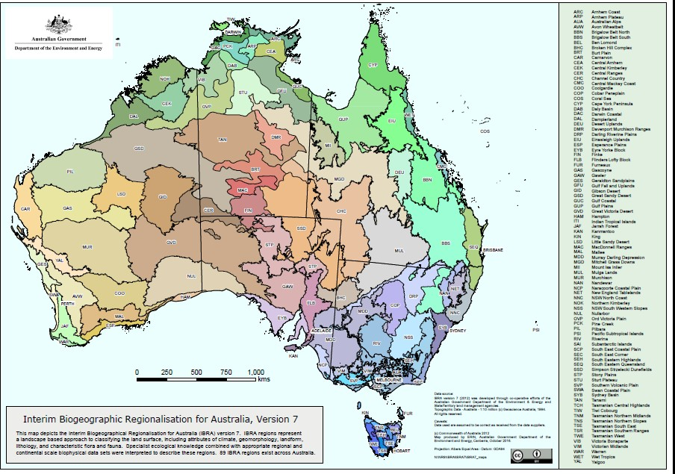Under the UN Convention on Biological Diversity (Secretariat of the Convention on Biological Diversity 1992), Australia has worked towards a target of 17 per cent of our continent to be protected as part of the National Reserve System. In building the National Reserve System, priority is given to under-represented bioregions that have less than 10 per cent of their remaining area protected in reserves. Other priorities include: key habitats for nationally listed threatened species or migratory species and/or Ramsar sites or wetlands of national importance; and areas that contribute to whole-of-landscape conservation outcomes, such as places that offer refuge and/or contribute to connectivity and the adaptation of biodiversity to changing climate.
Figure H.14 Interim Biogeographic Regionalisation of Australia, Version 7
Source: DAWE

There are 14 ecoregions found across the globe. Ecoregions contain geographically distinct groups of plants and animals that have evolved in relative isolation, separated by features such as oceans or high mountain ranges (Figure H.15). This classification system was developed by the conservation organisation, WWF, as a more comprehensive conservation tool than simply looking at ecosystem types, or biomes, based on climate and vegetation. Each ecoregion contains several biomes and biomes may transcend ecoregion borders.
Figure H.16 show the IBRA regions in Australia with less than 10% protection, showing that Australia still has some progress to make to achieve its targets that Australia has set for itself under the UN Convention on Biological Diversity.
The National Reserve System (NRS) is Australia's network of protected areas, conserving examples of our natural landscapes and native plants and animals for future generations. The NRS is based on the IBRA and ‘CAR’ scientific frameworks mentioned above, to ensure that Australia progressively extends protection to examples of all our ecosystems and is the nation's natural safety net against Australia’s biggest environmental challenges.
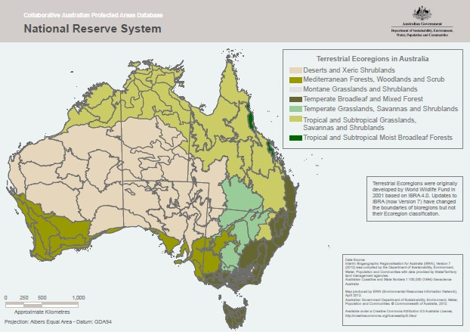The NRS Program was established in 1997 as part of the $3 billion Natural Heritage Trust to accelerate the protection of Australia's landscapes, flora and fauna for future generations. Since that time, the Australian Government has invested more than $80 million to build the National Reserve System, adding more than 20 million hectares to Australia's protected land areas.
Figure H.15 Terrestrial Ecoregions in Australia
Source: DAWE

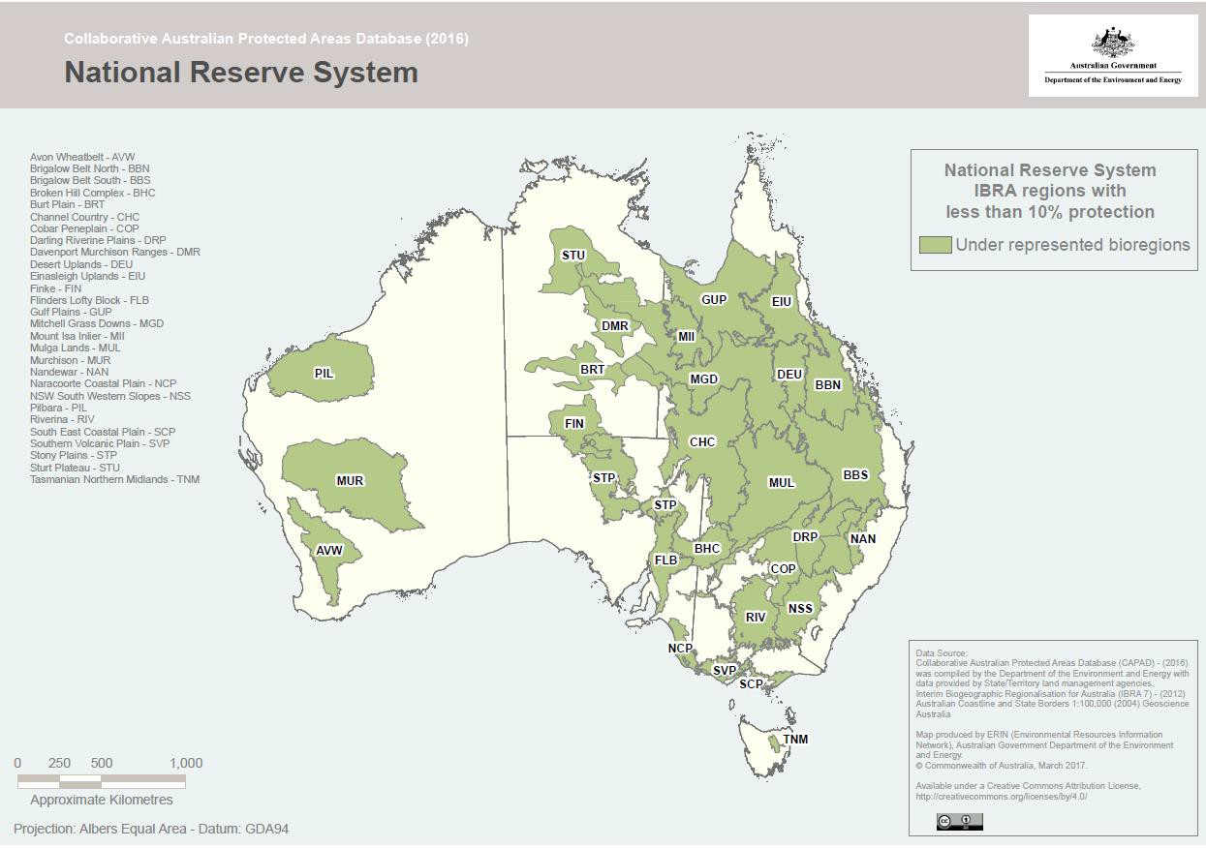

Figure H.16 IBRA regions with less than 10% protection
Source: DAWE

The NRS includes more than 10,500 protected areas covering 19.63 per cent of the Country - over 150 million hectares (Figure H.16). It comprises Commonwealth, state and territory reserves, Indigenous lands and protected areas run by non-profit conservation organisations, through to ecosystems protected by farmers on their private working properties. While governance and institutional arrangements vary between jurisdictions, four types of protected areas are recognised in the NRS:
- public reserves (or government-owned);
- IPAs;
- private protected areas; and
- shared management reserves.
The guidelines for the National Reserve System Plans of Management include information on some of the main elements of protected area management, including adaptive management, management effectiveness, and monitoring and evaluation.
Figure H.17 shows the terrestrial and marine protected areas in Australia under the NRS and NPRSMPA.

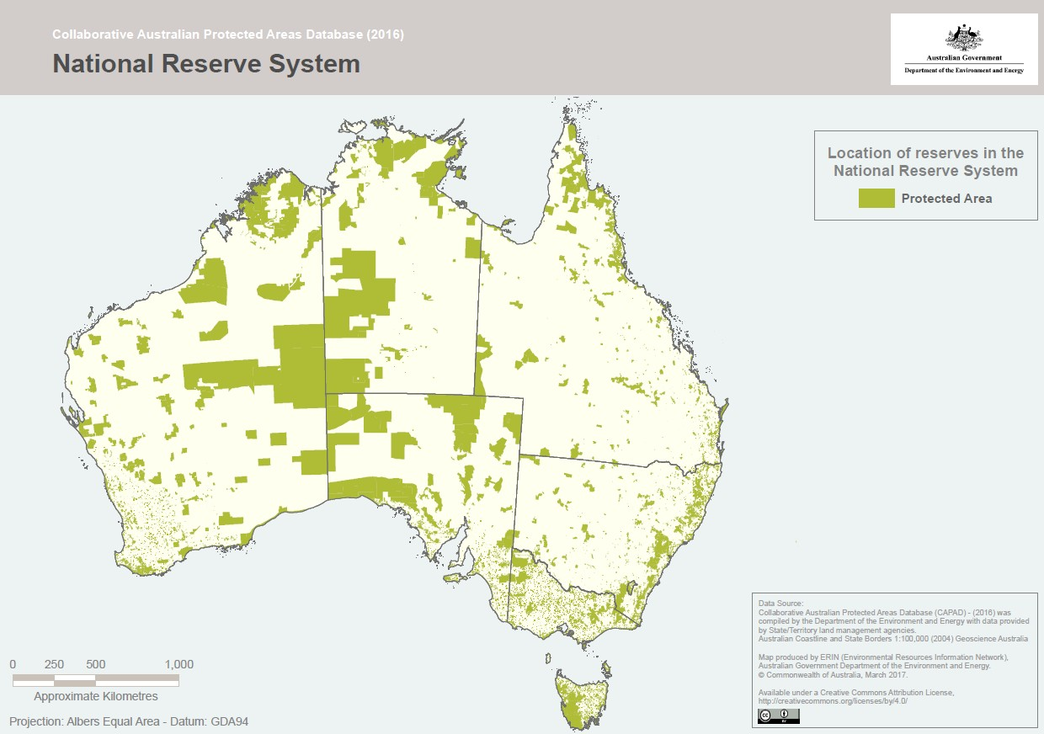

Figure H.17 National Reserve System – Terrestrial Protected Areas
Source: DAWE
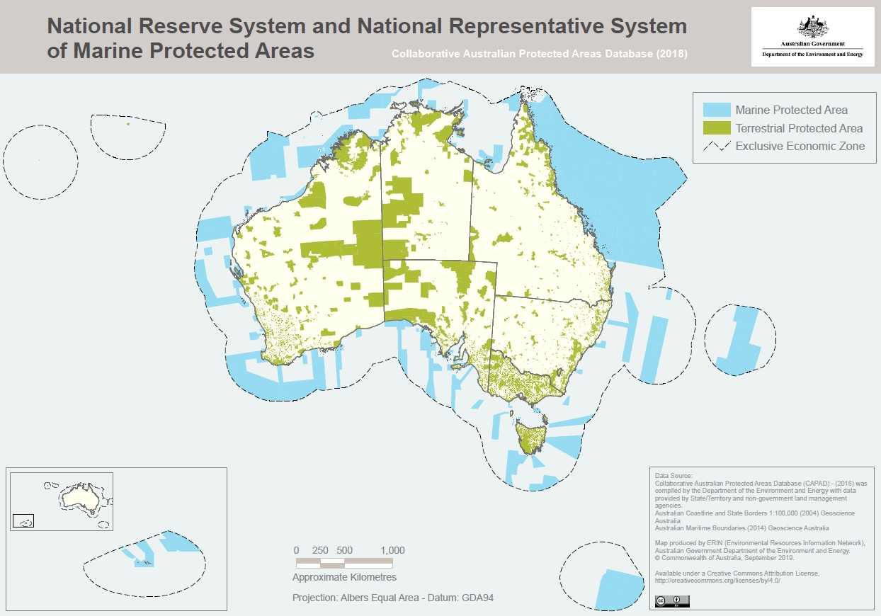
Figure H.18 National Reserve Systems and National Representative System of Marine Protected Areas
Source: DAWE

The next 20 years will be a critical period for biodiversity conservation in Australia, and the National Reserve System Strategy 2009-2030 (NRMMC, 2010) is an important step towards long-term protection of Australia's biodiversity.
The Strategy states that the foundation of the NRS must be based on strong partnerships between the Australian Government and the various state, territory and local governments, with a commitment to ongoing collaboration and sharing of information and resources. The NRS cannot be built solely on public lands and there is a significant role for Indigenous groups, local communities, private landholders and non- government organisations to play in establishing and managing protected areas to ensure the success of the NRS. The Strategy includes the following three targets:
- To expand the area that is protected within the National Reserve System to at least 125 million hectares (a 25 per cent increase), with priority to be given to increasing the area that is protected in under-represented bioregions;
- To expand the contribution of Indigenous Protected Areas (IPAs) to the National Reserve System by between eight and 16 million hectares (an increase of at least 40 per cent);
- To complete management plans for 100 per cent of Australian Government-funded protected areas under the National Reserve System within two years of the formation of agreements relating to these areas.
An IPA is defined by the Australian Government as:
an area of land and/or sea over which the Indigenous traditional owners or custodians have entered into a voluntary agreement with the Australia Government for the purposes of promoting biodiversity and cultural resource conservation.
An agreement with the Australian Government is required for an IPA to be eligible for support from the Australian Government. Indigenous people consider that IPAs are based on their own initiatives and continuing traditional responsibility for Country. At a national workshop in 1997, Indigenous delegates adopted the following definition of an IPA:
An Indigenous Protected Area is governed by the continuing responsibilities of Aboriginal and Torres Strait Islander peoples to care for and protect lands and waters for present and future generations. Indigenous Protected Areas may include areas of land and waters over which Aboriginal and Torres Strait Islanders are custodians, and which shall be managed for cultural biodiversity and conservation, permitting customary sustainable resource use and sharing of benefit. This definition includes land that is within the existing conservation estate, that is or has the ability to be cooperatively managed by the current management agency and the traditional owners. (Hill et al, 2011:1)
IPAs that are declared through voluntary agreement with the Australian Government form part of Australia’s National Reserve System, the network of formally recognised parks, reserves and protected areas across Australia.
There are currently 76 dedicated IPAs across approximately 67 million hectares (Figure H.19), plus 12 more sites currently under consultation (See Appendix I for details). The 76 IPAs account for more than 45 per cent of the National Reserve System's total area.
As well as protecting biodiversity, IPAs deliver cost-effective environmental, cultural, social, health and wellbeing and economic benefits to Indigenous communities. IPAs also protect cultural heritage into the future, and provide employment, education and training opportunities for Indigenous people in remote areas.
The formation of IPAs, the benefits of IPAs, IPA Management Plans and their role in environmental and climate science research are discussed in more detail in Chapter 6.

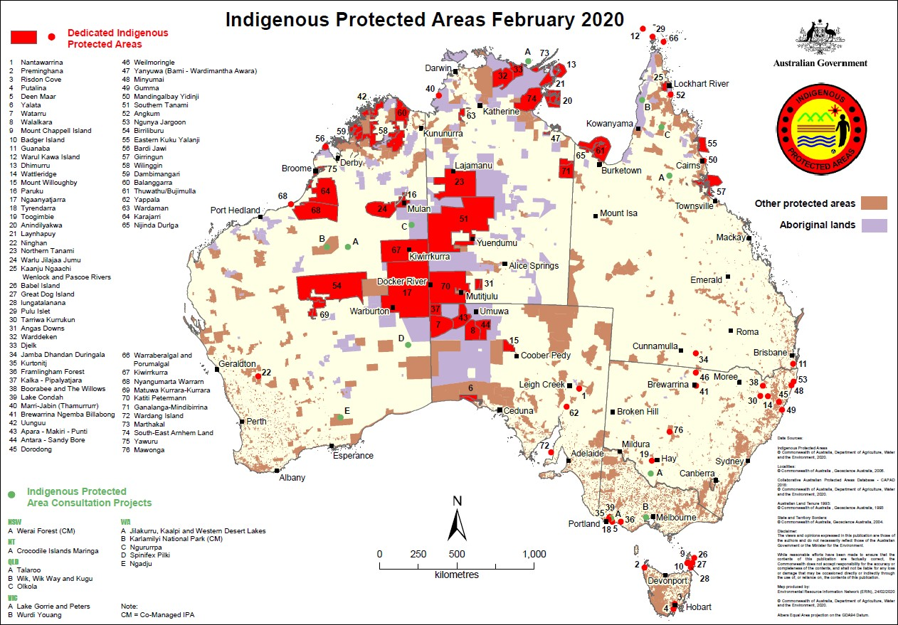

Figure H.19 Indigenous Protected Areas and Consultation Projects – February 2020
Source: DAWE, 2020

Indigenous heritage
Aboriginal and Torres Strait Islander heritage is an important part of Australian heritage, and all levels of government in Australia have broad responsibilities for recognising and protecting Australia's Indigenous heritage. Evidence of the occupation of Australia by Aboriginal and Torres Strait Islander people dates back more than 60,000 years. As well as historically important, Indigenous heritage is of continuing significance, creating and maintaining continuous links with the people and the land. Places that hold great meaning and significance to Indigenous people include:
- places associated with Dreaming stories depicting the laws of the land and how people should behave;
- places that are associated with their spirituality;
- places where other cultures came into contact with Indigenous people; and
- places that are significant for more contemporary uses.
Australia's state and territory governments have broad responsibilities for recognising and protecting Australia's Indigenous heritage, including archaeological sites. The Australian Government has a range of laws to protect Indigenous heritage, including the EPBC Act, the Aboriginal and Torres Strait Islander Heritage Protection Act 1984 (Cth) and the Protection of Movable Cultural Heritage Act 1986 (Cth).
The Aboriginal and Torres Strait Islander Heritage Protection Act 1984 (Cth) enables the Australian Government to respond to requests to protect important Indigenous areas and objects that are under threat, if it appears that state or territory laws have not provided effective protection. The Australian Government can make special orders, called declarations, to protect traditional areas and objects of particular significance to Aboriginals in accordance with Aboriginal tradition from threats of injury or desecration. However, the government cannot make a declaration unless an Indigenous person (or a person

representing an Indigenous person) has requested it. The power to make declarations is meant to be used as a last resort, after the relevant processes of the state or territory have been exhausted.
The EPBC Act establishes the National Heritage List, which includes natural, Indigenous and historic places that are of outstanding heritage value to the nation. The Act also establishes the Commonwealth Heritage List, which comprises natural, Indigenous and historic places on Commonwealth lands and waters or under Australian Government control, and identified by the Minister for the Environment (the Minister) as having Commonwealth Heritage values (such as the Uluru-Kata Tjuta National Park in the NT).
The Australian Heritage Council (the Council) is the Australian Government's expert advisory body on heritage matters. It includes Indigenous experts, who must be Indigenous people with appropriate heritage experience or expertise, at least one of whom represents the interests of Indigenous people on the Council. When a place is nominated for inclusion in the National or Commonwealth Heritage lists, and the Council considers that it may have Indigenous heritage values, the Council must endeavour to identify the Indigenous people with rights and interests in the place. It must then invite their views on whether the place should be included in the list. The Minister takes those submissions into account when making a decision about listing the place.
The Regulations to the EPBC Act includes the requirement for management plans for World, National and Commonwealth heritage places and the application of a set of management principles. Including that the management of these places should make timely and appropriate provision for community involvement, especially by people who:
- have a particular interest in, or associations with, the place; and
- may be affected by the management of the place.
Indigenous Australians are involved in developing management plans for places with Indigenous heritage significance on the National or Commonwealth Heritage lists. National heritage places on Indigenous land can be managed through conservation agreements, which operate in the same way as Indigenous Protected Areas.
For National and Commonwealth heritage places, Indigenous people are the primary source of information on the value of their heritage and that the active participation of indigenous people in identification, assessment and management is integral to the effective protection of indigenous heritage values.
For declared World Heritage places, the primary purpose of management of the natural and cultural heritage values of the property must be, in accordance with Australia’s obligations under the World Heritage Convention, to identify, protect, conserve, present, transmit to future generations and, if appropriate, rehabilitate the World Heritage values of the property.
Where the Minister considers that the heritage values of a place in the National or Commonwealth Heritage Lists could be significantly damaged by the disclosure of some information, the Minister may decide to make publicly available only a general description of the place, its location or its national heritage values.
Under the EPBC Act, there are penalties for anyone who takes an action that has or will have a significant impact on the national heritage values of a place.
Also under the EPBC Act, the Minister must table a report in the Parliament at least once in every five years on the National Heritage List and the Commonwealth Heritage List (S.324ZC and s.341ZH respectively). The most recent report on the heritage lists covers the five years from 1 July 2013 until 30 June 2018 (DEE, 2019). In relation to Indigenous heritage, the Report makes the following points:
- The Australian Heritage Council’s preferred approach to National Heritage nominations of Indigenous heritage is that they be led by the relevant Indigenous communities with the support of the relevant State or Territory government. This approach of strong partnerships with Indigenous communities ensures obligations around free, prior and informed consent are met. This enables

Indigenous people to take leadership in identifying Indigenous heritage places for potential recognition in the National and World Heritage lists.
- In May 2018, Chairs and senior officials from Aboriginal and Torres Strait Islander heritage organisations and agencies joined the annual meeting of the Heritage Chairs and Officials of Australia and New Zealand (HCOANZ) for the first time and were invited to become permanent members of HCOANZ. The HCOANZ forum, led by the Chair of the Australian Heritage Council and the forum host, the chair of the Northern Territory Heritage Council, issued the Darwin Statement.²⁰ The statement affirms the need to include, engage and collaborate with Aboriginal and Torres Strait Islander people and share their cultural heritage stories.
The Department continues to support Australia’s iconic World Heritage properties through targeted funding, including baseline funding for the management of the Wet Tropics of Queensland and the Tasmanian Wilderness World Heritage Areas, and new bilateral agreements with the relevant States with funding for World Heritage Executive Officers and/or Advisory Committees at 11 World Heritage properties in New South Wales, Queensland, Western Australia and South Australia.

Commonwealth National Parks
The Australian Government manages the following three National Parks jointly managed with Aboriginal people.
Booderee National Park which stretches across 6,379 hectares at Jervis Bay on the south coast of New South Wales. The park includes 875 hectares of marine environment. The park is also home to Australia’s only Aboriginal-owned and managed Botanic Gardens which takes up another 80 hectares. First established as a national park in 1992, today Booderee is jointly managed by its traditional owners and Parks Australia.²¹
Kakadu National Park, 240 kilometres east of Darwin in the Northern Territory, Australia’s largest terrestrial national park and covers almost 20,000 square kilometres. Kakadu is on the World and National Heritage Lists and its Board of Management has an Aboriginal majority representing the traditional owners, showcasing how 'joint management' can combine ancient culture and modern practice.²²
Uluru-Kata Tjuta National Park in the Northern Territory, about 450 kilometres southwest of Alice Springs by road. The park, 1,325 square kilometres in size. Uluru-Kata Tjuta National Park is also on the World and National Heritage Lists. The Park is Aboriginal land, jointly managed by its traditional owners Anangu and Parks Australia. First declared a national park under Commonwealth law on 24 May 1977, the Australian Government handed the deeds to the park back to its Anangu traditional owners on 26 October 1985.
Anangu is leased to the Director of National Parks and is jointly managed under a board comprising of a majority of traditional owners.²³

National Landcare Program
The National Landcare Program (NLP) is investing in projects that build on partnerships with Indigenous people and communities so they have the opportunity to fully participate in land and sea management, drawing on their significant and unique knowledge, skills and responsibilities.
Indigenous people have cared for and managed this continent for millennia and continue to care for their Country today. The natural resource management sector has strong Indigenous participation and has

20 http://www.environment.gov.au/system/files/resources/94665a8c-2e41-4aa3-915f-77a1a6af0199/files/darwin-statement- hcoanz.pdf
21 https://www.environment.gov.au/system/files/resources/a2e62555-5889-4110-995a-84c32739ecb8/files/booderee- management-plan-2015-2025-web.pdf
22 https://www.environment.gov.au/system/files/resources/1f88c5a3-409c-4ed9-9129-ea0aaddd4f33/files/kakadu- management-plan-2016-2026.pdf
23 https://www.environment.gov.au/system/files/resources/f7d3c167-8bd1-470a-a502-ba222067e1ac/files/management- plan.pdf

significant potential to further expand Indigenous involvement and build the capacity of emerging Indigenous natural resource managers.
The National Landcare Program is currently investing in a number of important projects involving Indigenous peoples in a number of different ways, including:
- on-ground natural resource management (NRM) activities (e.g. fire, rehabilitation, weed or pest management);
- the recording and continued use, support and reinvigoration of IEK to underpin biodiversity conservation and the sustainable use of natural resources;
- employment and capacity building, including access to appropriate training, education, land and sea management planning, management activities and enterprise development;
- clear articulation of Indigenous land and sea aspirations in regional NRM plans and the development and implementation of regional NRM Indigenous participation strategies;
- development of land and sea management plans; and
- Indigenous Participation Strategies that provide a framework and practical guide for regional NRM organisations to partner with and include Indigenous people in the planning, consultation and implementation of NRM investment.
The National Landcare Program supports and invests in the recording, transfer and use of IEK to ensure that knowledge is not lost with the passing of Elders and knowledge holders, and it can be used properly to provide opportunities for Indigenous people to be fully involved in the protection, rehabilitation and/or restoration of environmental assets, threatened species, ecological communities and migratory species. The transfer of knowledge needs to be two-way; it is important that Indigenous peoples have access to scientific knowledge and best practice for natural resource management while the recording and use of Indigenous ecological knowledge needs to be in accordance with agreed protocols and with prior approval of the Indigenous custodians of the knowledge. Projects utilising IEK include:
- The recording and continued use, support and reinvigoration of IEK to underpin biodiversity conservation and the sustainable use of natural resources, including the use of IEK in the Alinytjara Wilurara regional plan.
- The use of traditional fire management to reduce the intensity of fires and play an important role in conserving biodiversity, including Savannah burns in Southern Gulf; Savannah burns in Rangelands; and Traditional cool burns in North East Catchment Management Authority.
- The use of Indigenous Ecological Knowledge in sustainable farming practices, including: Yarns on Farms in Glenelg Hopkins; Treatment of invasive plants in culturally significant landscapes in Mallee; and Invasive species management in culturally significant landscapes in Mallee.
- The two-way transfer of knowledge leading to improved opportunities for Indigenous peoples and improved outcomes for biodiversity.
The National Landcare Program also includes a Regional Land Partnerships component which provides many of the 56 regional NRM organisations around Australia with resources to work with local Indigenous people and communities. Many of these organisations have been in existence since the mid-1990s. While they have different constitutions (some are established by State Governments others through relevant Community Associations legislation and one, Ocean Watch, by the seafood industry) they have all been recognised as regional NRM organisations by the Federal Government as part of the Natural Heritage Trust and its successor programs including the National Landcare Program. An interactive map of the 56 regional NRM organisations can be found here: http://www.nrm.gov.au/indigenous-nrm/telling-the-story
Figure H 20 shows the 49 management units across Australia that were funded under the Regional Land Partnerships component of the National Landcare Program to support the delivery of 195 projects that aim to contribute to vital on-ground environment and agricultural projects across the country. many of these management units are part of the network of regional NRM organisations across Australia.

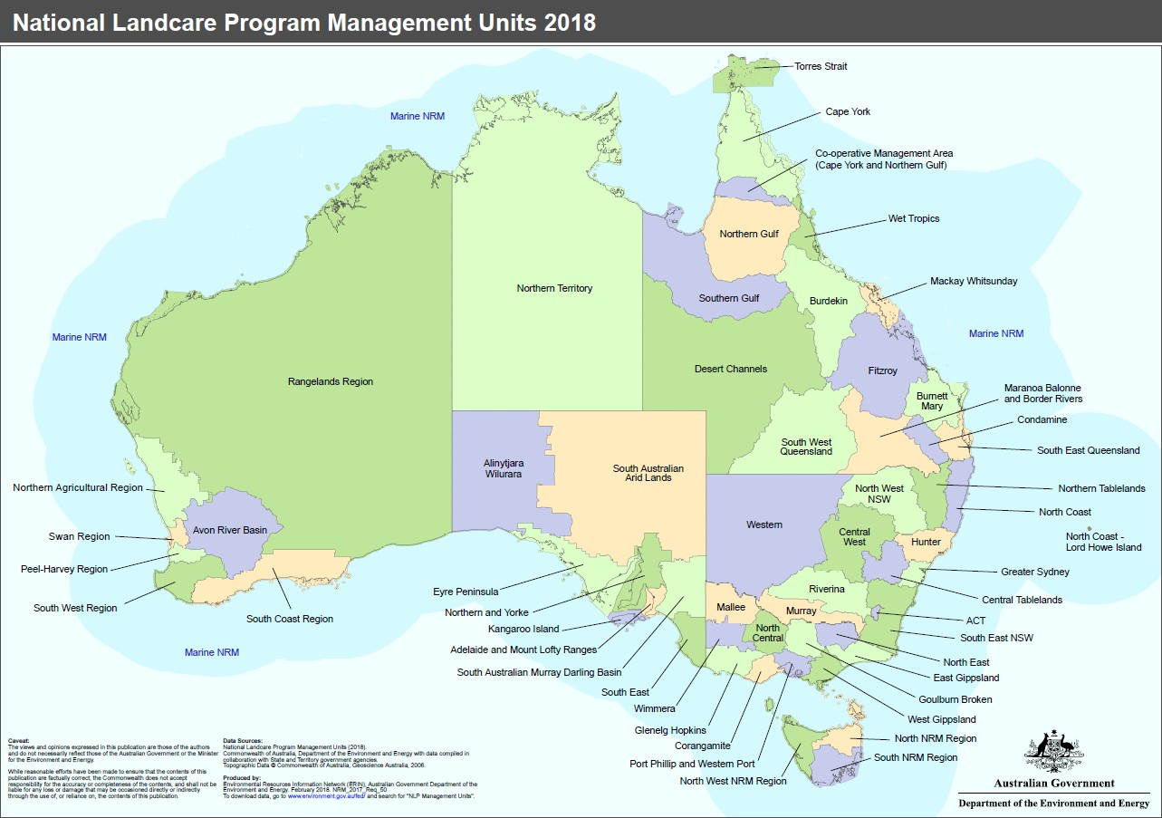The NRM regional organisations engage with Indigenous peoples on a wide range of activities including: on- ground delivery of biodiversity outcomes, NRM consultation and planning; recording and using Indigenous ecological knowledge, such as savannah and traditional cool burns; junior ranger programs; and sustainable agriculture. These activities contribute to wider social and economic benefits, such as Indigenous employment, training and enterprise development.
Figure H.20 National Landcare Program 2018 Regional Land Partnership Management Units
Source: DAWE http://www.nrm.gov.au/system/files/resources/83b10aba-cd7a-4068-bccb-c41b0cc7d5c1/files/national- landcare-program-management-units-2018-map.pdf

Commonwealth Environmental Water Office (CEWO)
The role of the Commonwealth Environmental Water Holder was established under the Water Act 2007 (Cth) to manage water acquired by the Australian Government as part of a suite of national water reforms, including the Murray-Darling Basin Plan.
The Department oversees the Sustainable Rural Water Use and Infrastructure Program (SRWUIP) which is a national program investing in rural water use, management and efficiency, including improved water
knowledge and market reform, and water purchase for the environment. It is the key mechanism to ‘bridge the gap’ to the sustainable diversion limits (the recovery of 2,075 GLs) under the Murray Darling Basin Plan.
The Commonwealth Environmental Water Holder’s plans take into account annual priorities and longer-term targets set within the Murray-Darling Basin Plan by the MDBA.
As discussed under the MDBA, the CEWO is co-funding the First Nations Environmental Water Guidance (FNEWG) Project with the MDBA to develop a defined and transparent methodology for First Nations’ environmental watering objectives to be incorporated in environmental water planning.

Australian Bureau of Agricultural and Resource Economics and Sciences and the inventory of Indigenous owned, managed or co-managed lands
The Australian Bureau of Agricultural and Resource Economics and Sciences (ABARES) is a research arm of the Australian Government Department of Agriculture, Water and the Environment.

ABARES’ mission is to provide professionally independent data, research, analysis and advice that informs public and private decisions affecting Australian agriculture, fisheries and forestry, and works at the interface between research and policy, with strong connections to agricultural, fisheries and forest industries, with strengths across agricultural and natural resource economics and sciences.
ABARES undertakes a number of different activities:
- data collection and management, including undertaking farm, forestry and fisheries surveys, publishing official statistics nationally and internationally, and ensuring the discoverability, accessibility and usability of our data holdings
- forecasting the price, volume and value of Australian agricultural output, for a wide range of farm, fishery, and forestry commodities
- undertaking and publishing public good research and analysis on issues of relevance to Australian agricultural, forestry and fisheries policy and industries
- providing analysis and advice directly to the Australian Government Department of Agriculture and Water Resources, and other government agencies.
ABARES’ work is arranged in nine themes under the three high-level objectives:
- Encourage and reduce risks to agricultural productivity
- Increase, improve and maintain markets
- Support sustainable high-quality natural resources.
In addition to ABARES’ three high-level research objectives, is improving data and knowledge systems.
Of particular interest to this review of Indigenous environmental and climate science research priorities under the NESP, is ABARES periodic State of the Forests Report because it monitors the degree to which land is placed under appropriate tenure classifications or management regimes to protect Indigenous peoples’ values in forests, and an acceptable level of accountability for the protection of Indigenous peoples’ cultural, religious, social and spiritual needs and values is an essential part of forest management.
The National Forest Policy Statement, issued in 1992 by the Australian, state and territory governments, sets out a vision and goals, objectives and policies for Australia's forests. It also commits Australia's governments to prepare a national 'state of the forests' review every five years on the status of Australia's forests. The State of the Forests Report (SoFR) meets this requirement, and also meets certain reporting requirements of the Commonwealth Regional Forest Agreements Act 2002 (Cth).
The relevance of the SoFR to this review of Indigenous engagement in the NESP is because the SoFR includes a national data set of four Indigenous land ownership and management categories.
Indicator 6.4a in the State of the Forests Report is about the area of forest to which Indigenous people have use and rights that protect their special values which are recognised through formal and informal management regimes. This indicator monitors the degree to which land is placed under appropriate tenure classifications or management regimes to protect Indigenous peoples’ values in forests. An acceptable level of accountability for the protection of Indigenous peoples’ cultural, religious, social and spiritual needs and values is an essential part of forest management.
For reporting purposes, the information collected on Indigenous land is grouped into four categories (Dillon
et al. 2015):
- Indigenous owned and managed: freehold lands that are both owned and managed by Indigenous communities.
- Indigenous managed: lands that are managed but not owned by Indigenous communities (e.g. Crown reserves and leases); and lands that are owned by Indigenous people, but have formal shared management agreements with Australian and state and territory government agencies (e.g. leased- back nature conservation reserves).

- Indigenous co-managed: lands that are owned and managed by other parties, but have formal, legally binding agreements in place to include input from Indigenous people in the process of developing and implementing a management plan (e.g. nature conservation reserve memoranda of understanding).
- Other special rights: lands subject to native title determinations, registered Indigenous Land Use Agreements and legislated special cultural use provisions. These are independent of tenure and, in most cases, do not grant ownership or management rights of land to Indigenous communities. They can provide for the right to access areas of cultural significance or the use of areas for cultural purposes (e.g. within protected water supply catchment areas), or can provide a legal requirement for consultation with the local Indigenous community before any major development activities take place.
A land parcel may be subject to more than one type of management. For this indicator, land is classified into the highest-ranked Indigenous land ownership and management category that is applicable (Dillon et al, 2015). For example, a land parcel that is subject to a native title determination, but that is also Indigenous owned and managed as a declared Indigenous Protected Area, is reported here as Indigenous owned and managed.
In 2016, the national Indigenous estate contained 438 million hectares of land, of which 69.5 million hectares was forested. This is 52% of Australia’s total forest area. Of the 69.5 million hectares of forested land in the Indigenous estate, 47.8 million hectares (69%) is in Queensland and the Northern Territory. The proportion of forested land that is in an Indigenous land category varies from 15% in New South Wales, to 79% in the Northern Territory.
The 69.5 million hectares of Indigenous forested land comprises 18.0 million hectares of forested land that is Indigenous owned and managed, 4.9 million hectares of forested land that is Indigenous managed, 5.7 million hectares of forested land that has Indigenous co-management arrangements in place with government agencies, and 40.9 million hectares of forested land over which Other special rights apply (including native title determinations and Indigenous Land Use Agreements). Figure H.21 shows the geographic distribution of the Indigenous forest estate across Australia by land ownership and management category.
Indicator 6.4a in the State of the Forests Report is about the extent to which Indigenous values are protected, maintained and enhanced through Indigenous participation in forest management. This indicator measures the extent to which Indigenous people participate in forest management. Active participation in forest management reflects the relationship between people and the land, and the integration of Indigenous peoples’ values with forest management practice, policy and decision making.
In the past, the forest sector has dealt with Indigenous issues mostly in terms of archaeological cultural heritage sites, placing less emphasis on the values associated with a cultural or spiritual attachment to the land. However, the understanding by the forest sector of Indigenous values has changed significantly in recent years. In part, this is due to contemporary civil movements for social justice and land rights, and the greater community awareness and recognition of Australia’s First Peoples. These have led to greater institutional commitment to increasing employment, consultation and inclusion of Indigenous peoples in land management. Larger numbers of Indigenous people are now employed in government agencies responsible for nature conservation or commercial wood production, and Indigenous people have a greater presence on natural resource management committees and in other forest-stakeholder forums. Lastly, there is also growing recognition that traditional knowledge can inform forest management, especially in relation to management of forest fire regimes.
The State of the Forests Report notes that while the level of Indigenous participation in forest management through various mechanisms may be difficult to measure, Indigenous people provide critical knowledge that contributes to the protection and maintenance of forest values independently of any legal right to the land. The Report also notes that the joint management arrangements applied in Kakadu and Uluru-Kata-Tjuta

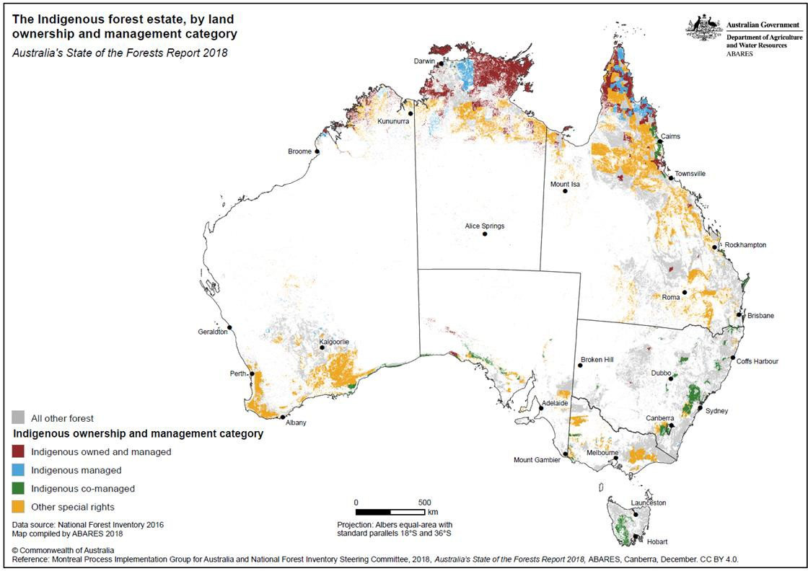
National Parks are a blueprint for joint management arrangements more broadly, not just in Australia, but also internationally (ABARES, 2018:423).
Figure H.21 The Indigenous Forest Estate by land ownership and management category
Source: ABARES 2018:403

