APPENDIX G: SELECTED NESP HUB

SYNTHESIS OR GROUND BREAKING PROJECTS OF ENDURING VALUE

The following NESP Hub research projects or activities are considered by SGSEP as being a synthesis or ground-breaking project with enduring value.

CAUL Hub
CAUL Hub Project 4.7: Towards an Indigenous-led research agenda
This project came out of previous CAUL Hub projects with Indigenous people contributing to the framing of this research and communicating the importance and need for further research. Using Indigenous engagement from the outset, this project responded to longstanding calls by Indigenous communities to consider access to land as a part of sustainable urban futures. Too often Indigenous communities are only 'consulted' about the project once all the important decisions have already been made. This project focused on Sydney and Melbourne and traced how local governments develop green infrastructure strategies and points to the pathways that urban decision-makers such as planners, arborists and environmental professionals can use in developing green infrastructure.
Ground-breaking:
This project was aimed at working out better models for enabling Indigenous communities to define and direct research that is of importance and value to them. The outcomes of this research will better inform University-based urban researchers about designing their research so that Indigenous communities are co- designing and co-governing the projects.
One of the outputs of this project is a report prepared by Libby Porter and Lauren Arabena, titled ‘Flipping the Table: Toward an Indigenous-led urban research agenda’ (Porter and Arabena 2018). This report is significant because it discusses how research needs to move beyond a model of ‘inclusion’ of Aboriginal and Torres Strait Islander peoples in research and teaching (especially within an urban context), and to ‘flipping the table’ whereby Indigenous approaches to research and methodology are viewed as being akin to Western approaches. Consequently, this requires researchers and practitioners to give deep and sustained consideration to research governance if Indigenous inputs to research are to be taken seriously.

ESCC Hub
ESCC Hub Project 3.2 Meeting Indigenous priorities for climate change information, capacity building and engagement
The first Indigenous Dialogue on Climate Change that was held at the Dharnya Cultural Centre Barmah, Victoria, in November 2018 was planned with assistance from an Indigenous-led Steering Committee, including the co-hosts the Yorta Yorta Nation Aboriginal Corporation (YYNAC), Kimberley Land Council (KLC), and SEED (Indigenous Youth Climate Network).
The ESCC Hub supported more than 50 Traditional Owners from across Australia met to converse on climate change, sharing their observations, talking about their priorities and exploring opportunities to improve knowledge of climate change and its risks for people and Country.

Ground-Breaking:
Importantly, the two-way dialogue between researchers and Traditional Owners working on climate change helped improve the understanding of mutual goals and potential benefits from working together
to support the community’s climate information needs. The dialogue also highlighted the importance of an ongoing dialogue and made clear that First Peoples want to set their own agenda on climate knowledge and action. This dialogue has been recorded in a co-authored report from the workshop (Morgan et al 2019).
An Indigenous Steering Committee is planning the second Indigenous Dialogue on Climate Change, originally planned for 2020, but now more likely to be held in early 2021.²

MB Hub
In 2016 the Executive of the MB Hub recognised that while some of Australia’s marine researchers understood the importance of Indigenous engagement in marine research, the majority did not, and more than likely, did not have the capability to effect it. The MB Hub realised that under these conditions it would be challenging for the MB Hub to effectively implement its IEPS and address the MB Hub’s research priorities. To maximise the chances of success in this area, and contribute to addressing the larger issue, the MB Hub instigated two initiatives to promote and review efforts in Indigenous engagement and participation.
Partnership with AMSA and Annual AMSA Conference workshops
The first was to champion and fund a partnership with the Australia Marine Sciences Association (AMSA) designed to promote Indigenous engagement and participation in Australia’s marine research by convening a series of annual Indigenous engagement workshops. An important part of this approach was to promote engagement and participation in both northern and southern Australia, given historical research efforts appear to have strongly favoured engagement with the former. shows how the MB Hub has progressed Indigenous engagement and participation in Australia’s marine research community by convening a series of annual Indigenous engagement workshops in partnership with AMSA. Figure G. 1 shows the four annual workshops that were convened from 2016 to 2019, including URLs to each of the workshop reports. A fifth workshop was to have been convened at the 2020 AMSA Annual Conference, but has been postponed due to COVID-19.
As Table G. 1 shows, the workshops between 2016 and 2018 were largely focused on raising the profile of Indigenous participation in marine science providing good examples of Indigenous sea Country aspirations, collaborative sea Country research in tropical and temperate Australia, and lessons learnt from collaborative research on sea Country.
The 2019 workshop was more ambitious and designed to promote the establishment of collaborative and respectful partnerships for sea Country research and monitoring in WA. The 2019 workshop was strategically targeted with direct invitations to managers and executive level positions in both Indigenous organisations and marine science providers operating in Western Australia.

2 http://nespclimate.com.au/supporting-a-national-dialogue-on-the-climate-change-science-needs-of-indigenous- communities/

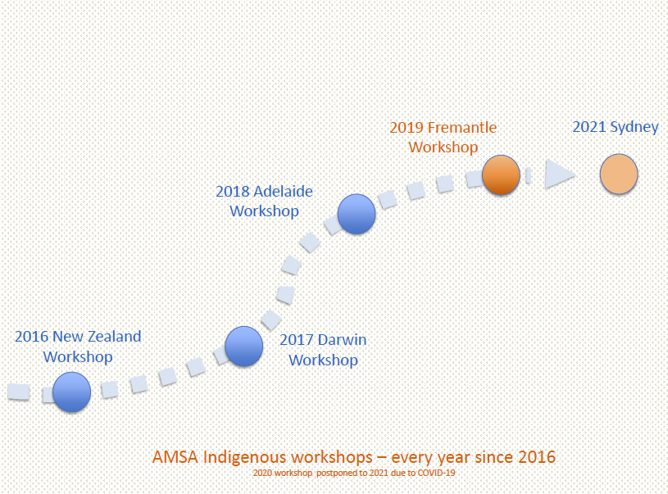
Figure G. 1 Progression of Indigenous engagement in marine research workshops in partnership with AMSA and their annual conferences
Source: Supplied by MB Hub.
Table G. 1 Leadership and collaborative efforts by the MB Hub to promote partnerships for sea Country research at AMSA Annual Conferences

Year | Workshop Location | Workshop title | Workshop report
2016 | Wellington, NZ | To open up a dialogue between indigenous peoples (practitioners, researchers and leaders) and the marine science community. It also aims to strengthen learnings and relationships across the Tasman | Description of panel discussion (URL provided)
2017 | Darwin, NT | To promote Indigenous engagement in marine science by sharing information on successes and identifying what can be done to advance meaningful collaboration. | Workshop summary report (URL provided) (Hedge 2017)
2018 | Adelaide, SA | To share information to support a shift towards better co-developed, co-delivered and culturally inclusive marine research with Indigenous communities. | Workshop summary report (URL provided) (Reinhold et al  2019)
2019 | Fremantle, WA | To promote the establishment of collaborative and respectful | Workshop summary report (URL provided) (Hegde and Bax 2019), and companion document providing a detailed

 |  | partnerships for sea Country research and monitoring in Western Australia (WA). | snapshot of indigenous, science and management agency partners for research and monitoring in Western Australia https://www.nespmarine.edu.au/document/promoting- partnerships-sea-country-research-and-monitoring- western-australia-snapshot (URL provided) (Lincoln and Hedge 2019)
2020 | Sydney, NSW | In development | Workshop postponed due to COVID-19.

The MB Hub reports that the 2019 workshop was very effective in bringing key people together to discuss standards for Indigenous engagement and priorities for research and monitoring on sea Country in WA. The Indigenous participants outlined a vision for an Indigenous engagement standard in WA (with the view that this should be national). The standard included three levels:
- a higher-level standard for Indigenous engagement in the ‘saltwater sector’ (the example provided was the Forest Stewardship Council model);
- a second level based on a broadly applicable principles approach to Indigenous engagement in sea Country research and monitoring (the preferred option being the AIATSIS Guidelines); and
- a third more detailed level focused on regionalised protocols for Indigenous engagement in sea Country research and monitoring (the existing example provided was the Kimberly Saltwater Research Protocol).
The 2019 workshop also pointed to the need for more effective coordination by the research providers to work together in engaging Traditional Owners, who otherwise would not have the resources to engage effectively in multiple independent (or duplicative) projects. The MB Hub found that the NESP Hub is one way of bringing research providers together in a particular field or theme. In addition to the workshop report, the MB Hub commissioned a document providing a detailed point-in-time snapshot of indigenous, science and management agency partners for marine research and monitoring in Western Australia (Lincoln and Hedge 2019).
MB Hub Baseline survey of Marine Scientists’ understanding of the need to engage with Indigenous
peoples
The MB Hub’s second initiative was to establish baseline data for understanding the motivations,
perceptions and practices of Australia’s marine scientists for Indigenous engagement in their research. The survey was completed in 2017 with results presented at the 2017 AMSA Conference. A scientific manuscript explaining the research findings has been submitted for publication in 2020, and there are plans to repeat the survey within 5-10 years of the baseline to understand changes in motivations, perceptions and practices.
Ground-Breaking:
What MB Hub’s approach confirms is that developing an arrangement with a peak professional association has considerable merit as a way of raising awareness, understanding and acceptance of the need to better engage with Indigenous peoples about research on their traditional land and sea Country. The 2017 survey provides a baseline from which to measure progress in future surveys and to understand changes in motivations, perceptions and practices with respect to Indigenous engagement by marine scientists.
The actions initiated by the MB Hub worked really well because the peak professional association for the marine science research discipline was willing to work collaboratively with the MB Hub. The MB Hub’s strategy of engaging directly with AMSA to raise the level of awareness and knowledge about the need to engage with Indigenous peoples about marine science research on their sea Country and to set in train a baseline data project to monitor changes in motivations, perceptions and practices of Australia’s marine scientists, is also a clear demonstration of the MB Hub’s commitment to increasing the level and quality of Indigenous engagement in marine research and building capacity within the discipline over time. SGSEP

agrees that the MB Hub can rightly claim leadership in promoting partnerships for sea Country research and monitoring.

NAER Hub
NAER Hub Project 5.3 Multiple Benefits of Indigenous Land and Sea Management Programs
Indigenous land and sea management programs (ILSMPs) are gaining a reputation for providing a core function in communities, with growing evidence of a variety of environmental, cultural, social and economic outcomes being delivered. This research provides quantified and comparable information about multiple, local to national scale socio-economic and wellbeing benefits associated with ILSMPs. The project was led by a Steering Group with senior Indigenous cultural advisers and key research stakeholders and two northern Australia Traditional Owners were part of the research team.
Synthesis and Ground-breaking:
The research shows that well-designed ILSMPs can:
- contribute to northern development and help close the (income) gap;
- promote Indigenous business development and economic independence;
- promote Indigenous wellbeing;
- facilitate knowledge exchange, which is important to Indigenous wellbeing;
- help Indigenous communities meet their wider aspirations.

NAER Project 5.4 Knowledge Brokering for Indigenous Land Management
Indigenous land management (ILM) occurs over significant proportions of northern Australia that contain many high-value environmental assets. Effective land management is vital to northern Australian development and Indigenous land managers have a strong desire to engage in the increasing level of development planning. Traditional Owners hold substantial knowledge about using, managing and
safeguarding northern Australia’s natural and cultural resources, and a significant body of scientific research is also available. However, these knowledge resources have not yet fully empowered Traditional Owners’ land management and development capability. Effective knowledge brokering can help overcome barriers and the project’s co-research approach places Indigenous people as central to driving the design, and testing of knowledge brokering tools. This project was led by a Steering Group with senior Indigenous cultural advisers and key research stakeholders and two northern Australia Traditional Owners were part of the research team.
Synthesis and Ground-Breaking:
The project has also produced the ‘Our Knowledge Our Way in caring for Country’ guidelines for strengthening Indigenous knowledge in land and sea management. The guidelines are based on 23 case studies from across Australia illustrating best practice for working with and strengthening Indigenous knowledge. The Guidelines will be hosted on NESP NAER, CSIRO and IUCN websites.

TSR Hub
TSR Hub Project 3.2.2.2: Monitoring Threatened Species on Indigenous lands: Bilbies in the Martu Determination
This project combined Indigenous knowledge and Western scientific techniques to create and establish bilby monitoring and data management programs that will be implemented by the Martu Kanyirninpa Jukurrpa Rangers. The project was co-directed by Martu to guide the development of methodology and ensure that the outputs are useful to end-users long-term, and that the data captured will be informative to national recovery planning. The monitoring program that came out of this project relies on the combination of Martu ecological knowledge and approaches to assessing Country with Western science to

deliver multiple benefits including enhanced data quality, improved ranger engagement, training opportunities and archiving of Indigenous knowledge.
Ground-Breaking
This project developed a threatened species monitoring program tailored to the requirements of Indigenous land holders to allow them to assess trends and make decisions to implement management on their lands. This required an approach that both respects the priorities of traditional owners and the needs of threatened species. It is a case study of good practice in integrating Indigenous ecological values and knowledge with Western science approaches to quantitative analyses. The information collected will guide management activities that Indigenous groups undertake to maintain and enhance bilby habitat and potentially other threatened species.

TWQ Hub
TWQ Hub Project 3.9: Indigenous capacity building and increased participation in management of Queensland sea country
For over 20 years, Traditional Owners (TOs) from across the Great Barrier Reef (GBR) have been coming together to explore and call for a collective approach to achieving their aspirations for ownership, access to, and involvement in the management of sea Country. Over these years, people have made real progress in securing improved recognition of their rights and developing local capacities to govern and manage their sea Country. Despite these wins, and good engagement by Commonwealth and State governments on occasions, there has been no lasting, continuously improving GBR-wide approach to engaging TOs. With the future health of the GBR under threat, the current Reef 2050 Long Term Sustainability Plan (Commonwealth of Australia 2018a) recognises the significance of Traditional Owner rights and interests in the management of sea Country and the Marine Park. There are considered and significant Indigenous implementation actions embedded right across Reef 2050. This research explored the options for a more “joined-up” approach across the GBR and revisited the TOs’ core aspirations regarding the management of sea Country. TOs from across the Reef were integrally involved in developing a coordinated framework for increasing Indigenous participation in sea Country management and providing information relevant to the development of an Indigenous-specific Strategy for progressing the Implementation Actions of the Reef 2050 Long Term Sustainability Plan (Commonwealth of Australia 2018b and Gidarjil Development Corporation 2016).
Synthesis and Ground-breaking:
The final report of the study explores the history of TO attempts to secure a more “joined-up” approach across the GBR and revisits their core aspirations regarding the management of sea Country (Dale et al 2016). It presents the results of consultation with TOs regarding the effective implementation of Reef 2050 and of the TWQ Hub’s Indigenous Engagement and Participation Strategy. The report provides the details of a coordinated Indigenous framework for sea Country management of the Reef and shows how Indigenous participation in sea Country management can be effectively increased.

