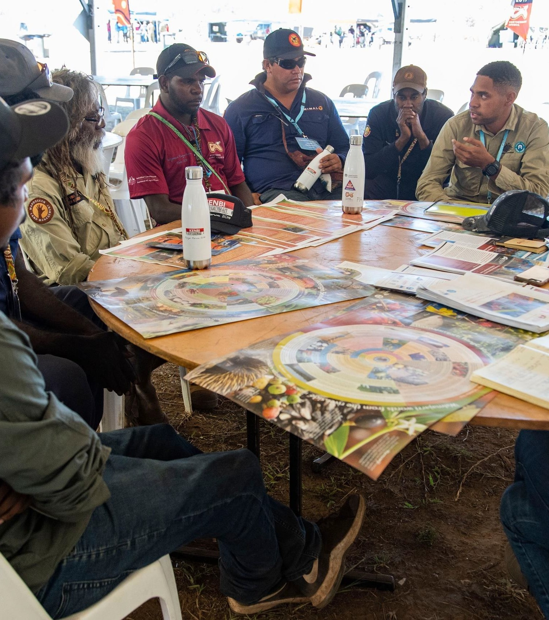

DESK-TOP REVIEW OF INDIGENOUS ENGAGEMENT IN THE
NATIONAL ENVIRONMENTAL SCIENCE PROGRAM (NESP) PART TWO – APPENDICES
FINAL REPORT | Prepared for
JULY 2020 | Department of Agriculture, Water and the Environment

Front Cover Photo: NT Rangers NT Ranger Forum discussing the Our Knowledge Our Way
Guidelines. Photo by Patch Clapp.
Rear Cover Photo: Stephanie Beaupark, Ngugi woman teaching Indigenous weaving techniques using Spiny-headed Mat-rush (Lomandra longifolia). Stephanie completed research for the CAUL Hub on air quality and Indigenous seasons and engaged with attendees through her practice. Photo by Sarah Fisher.

Citation:
Wensing, E. and Callinan, T. (2020) Desk-Top Review of Indigenous Engagement in the National Environmental Science Program (NESP). SGS Economics and Planning for the Department of Agriculture, Water and the Environment, Canberra. https://www.sgsep.com.au/projects/desk-top-review-of-indigenous-engagement-in-the-national-environmental-science-program

© SGS Economics and Planning Pty Ltd 2020
This report has been prepared for the Department of Agriculture, Water and the Environment. SGS Economics and Planning has taken all due care in the preparation of this report. However, SGS and its associated consultants are not liable to any person or entity for any damage or loss that has occurred, or may occur, in relation to that person or entity taking or not taking action in respect of any representation, statement, opinion or advice referred to herein.
The Report’s authors are:
- Dr Ed Wensing (Life Member) MPIA, FHEA, Special Adviser and Associate
- Tara Callinan, Senior Consultant
SGS Economics and Planning Pty Ltd ACN 007 437 729
www.sgsep.com.au
Offices in Canberra, Hobart, Melbourne, Sydney

Acknowledgement of Country

SGS Economics and Planning acknowledges the Traditional Owners on whose Country we live and work.
SGS Economics and Planning acknowledges that the Indigenous peoples of Australia are the oldest living culture on Earth, have the oldest continuing land tenure system in the World, and have the oldest continuing land use planning and management system in the World.
We acknowledge that the you have suffered the indignity of having your land taken from you without your consent, without a treaty, without compensation. We acknowledge these matters are yet to be justly resolved.
Dr Ed Wensing Tara Callinan

TABLE OF CONTENTS

Acknowledgement of Country | iii
APPENDIX A: LIST OF VIRTUAL CONSULTATIONS |  | 188
APPENDIX B: OPPORTUNITIES ARISING FROM NESP INDIGENOUS GATHERING 2018 |  | 189
APPENDIX C: OBJECTIVES OF EACH OF THE NESP HUB’S IEPS |  | 192

APPENDIX D: SELECTED NESP HUB RESEARCH PROJECTS AND DETAILS OF INDIGENOUS INVOLVEMENT OR ENGAGEMENT 195
APPENDIX E: NESP HUB RESEARCH PROJECTS BY DETAILS OF ‘INDIGENOUS LED’ 293
APPENDIX F: INDIGENOUS PARTICIPATION KPI’S 2017, 2018 AND 2019 297
APPENDIX G: SELECTED NESP HUB SYNTHESIS OR GROUND BREAKING PROJECTS OF ENDURING VALUE 302
APPENDIX H: COMMONWEALTH AGENCIES AND DEPARTMENTS, INDIGENOUS ENGAGEMENT AND RESEARCH PRIORITIES 308
APPENDIX I: IPA CONSULTATION PROJECTS FEBRUARY 2020 382
APPENDIX J: SPATIAL MAPPING OF SELECTED NESP HUB RESEARCH PROJECTS 385
APPENDIX K: NESP HUB PROJECTS NOT SPATIALLY MAPPED 425
APPENDIX L: COMPONENTS OF THE INDIGENOUS ESTATE 427
APPENDIX M: RESOURCES SUPPORTING INDIGENOUS ENGAGEMENT 429

